SUSTAINABILITY REPORT
INANC HOTEL
2025
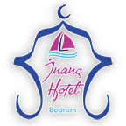
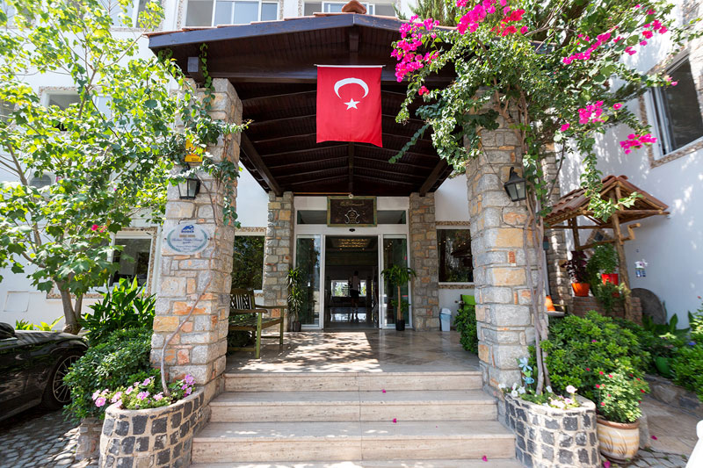
ESENDEMIR TOURISM TRAVEL TRADE FOOD JEWELLERY INS. EML. MOB. OPTIK CAR RENTAL ITH. AND IHR. LTD. STI.
CONTENTS
1. ABOUT THE REPORT 3
1.1. Sustainability Approach 3
1.2. Corporate Approach 4
1.3. Participatory Approach 4
1.4. Report Coverage 5
2. ABOUT THE FACILITY 6
3. SUSTAINABILITY 8
3.1. Our Sustainability Team 10
3.2. Our Sustainability Efforts 10
3.3. Purchasing Management 12
3.4. Environmental Management 13
3.5. Waste Management 14
3.6. Energy Management 15
3.7. Water Management 16
3.8. Chemical Management 18
3.9. Geographical Awareness 19
3.10. Collaboration with Local Communities and Social Responsibility 19
3.11. Communication and Relations with Stakeholders 19
3.12. Biodiversity and Natural Areas Protection 21
3.13. Wildlife Conservation and Support 22
3.14. Access for All 23
3.15. Personnel and Working Life 23
3.16. Our Guest Satisfaction 24
4. CULTURAL AND HISTORICAL HERITAGE 25
4.1. Bodrum Castle 26
4.2. Bodrum Ancient Theater 27
4.3. Myndos Ancient City 28
4.4. Myndos Gate 29
4.5. Mausoleum at Halicarnassus 30
4.6. Karakaya Village 31
4.7. Dibeklihan Culture and Art Village 32
4.8. Windmills 33
4.9. Ottoman Shipyard 34
4.10. Apostolic Church 35
4.11. Zeki Müren Art Museum 36
5. OUR POLICIES 39
5.1. Sustainability Policy 39
5.2. Quality Policy 40
5.3. Purchasing and Local Supplier Policy 41
5.4. Environment and Waste Management Policy 42
5.5. Human Rights, Employee Rights and Equal Opportunity Policy 43
5.6. Vulnerable Groups and Children's Rights Policy 45
5.7. Customer Satisfaction Policy 46
5.8. Occupational Health and Safety Policy 46
5.9. Energy Management Policy 47
5.10. Stakeholder Communication Policy 48
5.11. Restricted Individuals and Accessibility Policy 49
5.12. Food Safety Policy 50
5.13. Local Community Support Policy 51
5.14. Destination Participation Policy 52
5.15. Policy on the Protection and Presentation of Cultural Heritage 53
5.16. Biodiversity Conservation Policy 54
5.17. Wildlife and Animal Health Protection Policy 55
5.18. Local Employment Protection Policy 56
5.19. Local Awareness Policy 57
5.20. Water Conservation Policy 58
5.21. Sustainable Procurement and Supply Chain Policy 59
5.22. Harassment and Discrimination Prevention Policy 60
5.23. Staff Open Door Policy 61
5.24. Risk and Crisis Management Policy 62
5.25. Internal and External Communication Policy 63
5.26. Greenhouse Gas Emissions Reduction Policy 65
5.27. Performance and Promotion Policy 66
5.28. Internal and External Audit Policy 67
5.29. Education Policy 68
5.30. Recruitment, On-the-Job and Orientation Policy 69
6. OUR SAVINGS MEASURES 71
7. OUR GOALS 72

- ABOUT THE REPORT
  - Sustainability Approach
Sustainability; It refers to the use of environmental values and natural resources in a way that does not lead to waste, taking into account the rights and benefits of present and future generations. Purpose; While providing a balanced development in social, economic, ecological and cultural dimensions, it is to make development possible for today without risking the ability of future generations to meet their own needs.
Sustainable Tourism; A project called by the United Nations World Tourism Organization (UNWTO) "fully taking into account current and future economic, social and environmental impacts; tourism that meets the needs of visitors, industry, the environment and host communities".
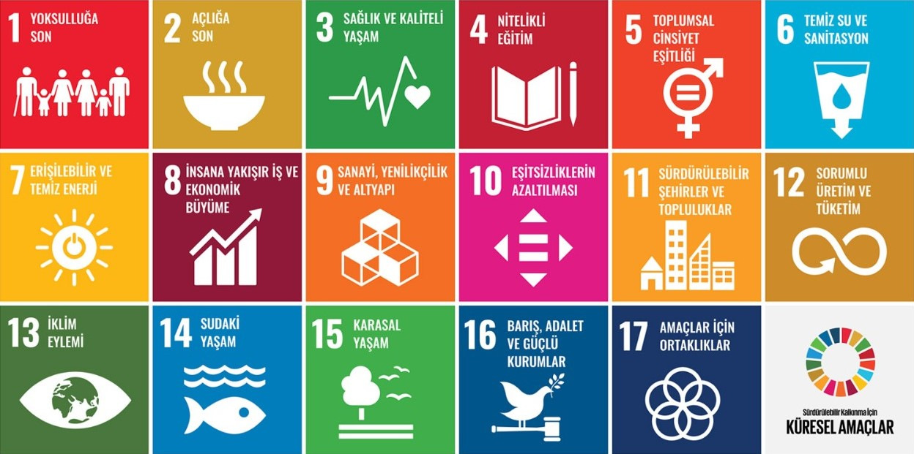
Figure 1.1.1: Global Goals for Sustainability Development

We pay attention to energy saving and use our energy as efficiently as possible. We take care to protect our energy and energy resources.
We pay attention to water conservation and take care to use our water efficiently as much as possible to reduce our water consumption.
We manage our waste in a controlled manner from the moment it is generated at the source. We always act sensitively to the environment by acting according to the Zero Waste System in terms of waste reduction.

  - Corporate Approach
Our facility, aware of its responsibilities in all dimensions of sustainable development, continues its efforts for a better world. Without compromising our high service standards and 100% guest satisfaction principle; controlling consumption, protecting natural resources and minimizing negative effects on the economy are among our primary goals.

In the areas we are involved in the life cycle;
We embrace the protection of social and cultural values and support non-governmental organizations.
In our product and service supplies, we prioritize local businesses and support their growth.
We contribute to sustainable development by choosing institutions and organizations that guarantee the rights of producers and workers and offer better trade conditions.

The main result we aim to achieve is to become aware of the changes that will shape the future and to implement them for a more sustainable life, as a requirement of our responsibility to future generations. For this;

We prefer and encourage cycling, an environmentally friendly mode of transportation that reduces carbon emissions to zero. We recommend public transportation such as buses, etc.
We are constantly complying with current regulations to make it possible for many people to use it regardless of age, skill and condition.

  - Participatory Approach
Our sustainability efforts; Our management is shaped by the contributions of our employees, guests, suppliers and business partners. By sharing this process transparently, we aim to raise awareness, adopt common goals and achieve success together.

  - Report Coverage
We aim to achieve all of the Sustainable Development Goals, which were created for the solution of social, cultural and ecological issues consisting of 17 main headings that United Nations member countries aim to achieve by the end of 2030, for our Sustainable Tourism Activities.
Our vision; To protect our brand value by creating more employment in hotel management and a livable environment for future generations with a sense of responsibility with reliable, respectful and environmentally sensitive works.
Our Mission; It is to be your home where we will experience the texture of the region with the most natural, cleanest and most real.
Our Obligations and Principles; We are obliged to operate in line with our values formed by our corporate culture, all kinds of legal laws, regulations and professional business standards.
Our main principles in all these activities are to ensure our continuity with a human and environment-oriented approach, continuous development and sustainable resource management.
With our sustainable tourism approach, we aim to continuously improve our management style, staff, guest accommodation, perspective, sensitivities, resources, and all our hotel management activities from now on. We promise to improve ourselves within legal frameworks in order to leave livable resources to future generations and to give other living things the right to live on the planet we live in. From now on, we plan to share our activities in this context transparently with all our stakeholders. We would like to announce that we will be sharing the performance data on our development with our reports.
This sustainability report includes data from the last 1-year period and targets for the next year. While preparing the report, what we have done in our previous periods was also taken into consideration.
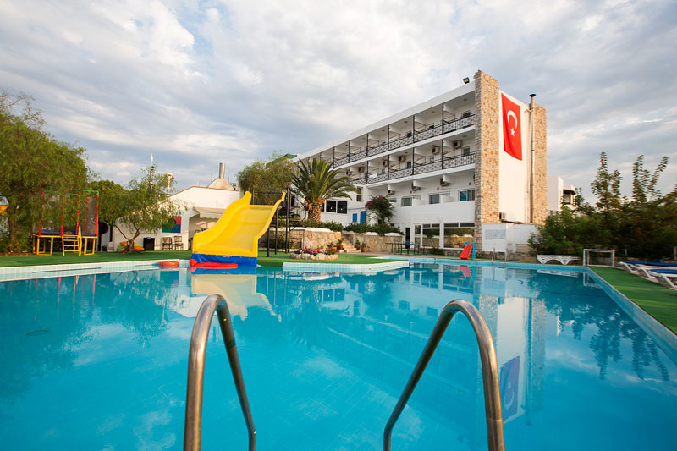
- ABOUT THE FACILITY
The features of our facility are as follows:
Accommodation : Half Board
Service Languages : Turkish, English
Nearest Airport : Milas Bodrum Havaalanı (BJV)
To the airport : 38 km
To the city center : 4 km
To the sea : 200 m
Hotel Building : 3 blocks with 2 floors
Construction Date of the Hotel : 1985
Last Renovation Date : 2024
Number of Rooms and Beds : 68 rooms and 136 beds
Elevator : None
Reception Service : 24 hours
Parking Facility : Free Outdoor Parking
Check-in and Check-out Times : 14:00-12:00
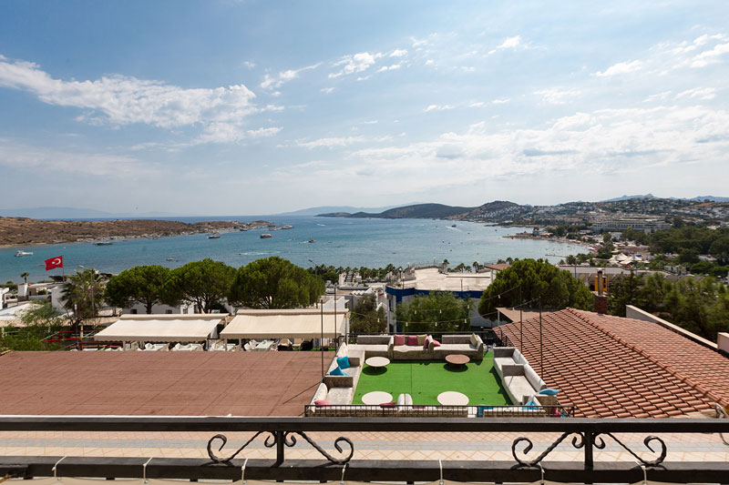

Pool Services:
Swimming Pool : 145 m² (Maximum 150 cm)
Children's Pool : 10 m² (Maximum 45 cm)
Pool Hours : 10:00 – 19:00
Pool Services : Changing Cabin, WC, Shower, Sunbed, Umbrella, Towel

Sports and Activities:
Children's Playground (Free)

You can use the following communication channels for your opinions.
Coordinates : Latitude 37.033575, Longitude 27.404791
Address : Gümbet Mh. Şakir Esendemir Sk. No:11 Bodrum/MUĞLA
Phone No : +90 533 618 47 52
Email : inanchotel@gmail.com
Website : https://www.inanchotel.com/
Facebook : https://www.facebook.com/bodruminanc.otel.7

- SUSTAINABILITY
In order to ensure the effective use of natural resources with the awareness of environmental responsibility; To minimize all kinds of wastes arising from resource consumption, to separate them at the source and to dispose of hazardous substances without harming the environment, to comply with and continuously improve the relevant laws and regulations, to contribute to instilling environmental awareness in our employees, guests, tour operators, suppliers and society, to make our policy a lifestyle, to ensure the continuity of our practices so that it spreads to all areas of our lives and to the public. It is our goal to keep it open to review
It aims to provide regular training to our employees, to prevent possible work accidents and occupational diseases by constantly improving their conditions, to identify the dangers and risks they may be exposed to in advance.
It is our occupational health & safety policy to raise awareness of all our employees with the help of trainings in order to protect human health and human rights in team spirit, to provide a safe and healthy working environment, to adopt the basic duty of not endangering the health and safety of themselves, other employees and our guests by complying with legal conditions and our own conditions, and to continuously improve the prevention culture by reviewing our risk analyses.
It aims to work to prevent the abuse of vulnerable groups without discrimination on issues such as race, gender and disability, and to increase the number and quality of local employment created by tourism, including increasing the quality of wages and services.
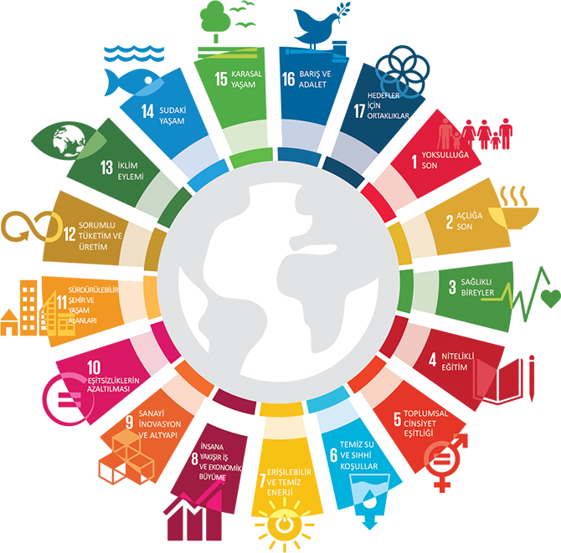
Figure 3.1: Sustainability Main Topics
Our Purpose:
- To protect nature and natural life,
- To protect our cultural heritage,
- To use resources more economically,
- To contribute to society with social responsibility activities,
- To increase the sense of belonging in our employees,
- To develop together and by learning, to protect our children and women, who are our most valuable assets, with a fair and egalitarian perspective,
- To be in more communication with the region and local people we are in, to benefit the opportunities to develop the region we are in.

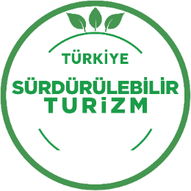
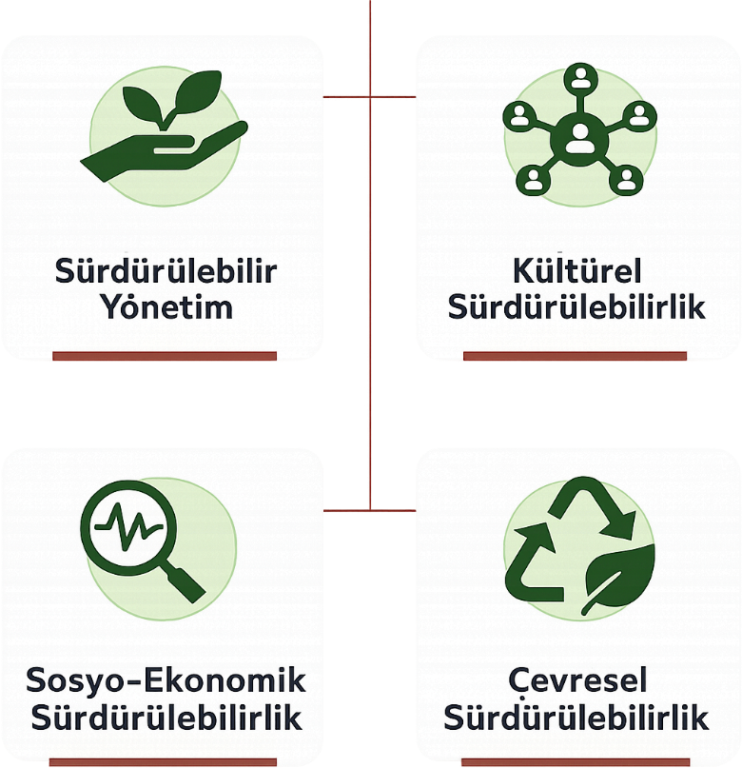
A Sustainable Risk Analysis covering the areas in the figure was carried out, and possible risks were identified and existing measures were defined. Efforts are made to ensure the sustainability of the system by planning the actions to be taken.
We continue our work with the awareness that we have to comply with all relevant legal regulations. In the legal legislation follow-up list, all legislation that we are obliged to comply with has been determined. We receive external support in areas outside our area of expertise. For example, our Occupational Safety Specialist: Occupational Safety Law and related Regulations, our Environmental Consultant: Environmental Legislation and related Regulations, etc. We closely follow the hotel industry with our memberships in relevant non-governmental organizations and associations, and we manage legislative changes in cooperation through these channels.
All legal permits and documents are available. Periodical documents are followed up regularly.
In order to measure our performance in the sustainability journey, indicators have been determined, targets have been set and monitored.

  - Our Sustainability Team
The main responsibilities of the team:
- Establishment of a Sustainability Management System,
- Preparation of the Sustainability Report,
- Setting goals,
- Preparation of relevant policies, procedures and instructions,
- Review of sustainability policies every 6 months,
- Ensuring the dissemination of sustainability principles within the hotel,
- Establishing a system and raising awareness about receiving stakeholder feedback,
- To develop projects on environment, cultural heritage, wildlife, biodiversity and social issues.
Frequency of Team Gatherings : Monthly (General) Every 6 months1 (System review/YGG)
Meeting Agenda : It is determined before the meeting.

  - Our Sustainability Efforts
Our facility is committed to providing accessible tourism services to everyone within its means and informs its customers and stakeholders about the level of accessibility clearly and accurately through its website.
To benefit cultural heritage and minimize damage to cultural heritage.
Our purchasing policy is aimed at local, environmentally responsible, fair trade-based and efficient purchasing. We control the sustainability-related processes of our suppliers.
To provide maximum satisfaction by determining the expectations and needs of our guests in advance.
To provide social and economic benefits to the people of the region and to minimize the negative effects on the people.
In our facility, it provides accurate information to all segments in promotion. It always uses real visual material in the promotion. Our facility has a transparent and realistic structure in terms of its products and services on its website, social media accounts and other printed and written promotion channels and marketing communication.
We take all necessary measures to increase local employment, protect and enrich natural life in the places where we are located, and share all our activities with the public in order to protect our environment.
With this sustainability report published on behalf of the facility, the sustainability performance and impacts of our facility are presented to the attention of all our stakeholders. We continue our activities as a tourism investment company that prioritizes guest satisfaction.
We protect the environment, prevent pollution, and attach importance to reducing our negative effects on the environment,
We try to use water, energy and all natural resources economically and we share this sensitivity with our employees, guests and suppliers,
We contribute to the protection of nature by choosing the materials we buy in our business with "recycling" and "environmentally friendly" labels. We are trying to create opportunities for reuse.
We measure our performance in environmental management, monitor this data with targets and try to improve our performance.
We follow national and international standards, laws and regulations in order to fulfill both our responsibilities towards nature and our legal obligations.
We store the wastes correctly in separate areas according to their characteristics, deliver them to licensed/authorized companies without exceeding the legal storage time limits and keep their records.
We support local/regional development and employment,
We respect the working rights of our employees and follow them within the framework of the provisions of the legal regulations.
We support the abolition of child labour.
We offer our employees the opportunity to develop and progress by providing regular training.
We offer our employees a healthy and safe working environment and offer various opportunities for them to convey their requests, suggestions and complaints.
We inform our guests and employees about the natural and cultural heritage of the local/region,
We evaluate all the feedback of our guests. We improve our processes in line with the data we obtain.
We evaluate and analyze the quality and quality of product/service purchases with users. We act fairly, honestly and impartially in supplier selection.
We respect human rights; We reject all forms of discrimination such as language, religion, race, gender, etc. We oppose any form of abuse or harassment, whether commercial, sexual, or otherwise, directed at specially protected groups and other vulnerable groups. We support measures to be taken against domestic violence and child abuse. We have one room for disadvantaged individuals. Pets are not allowed.
At the end of each year, we plan to evaluate our sustainability performance and share it online with all our stakeholders on our official website.
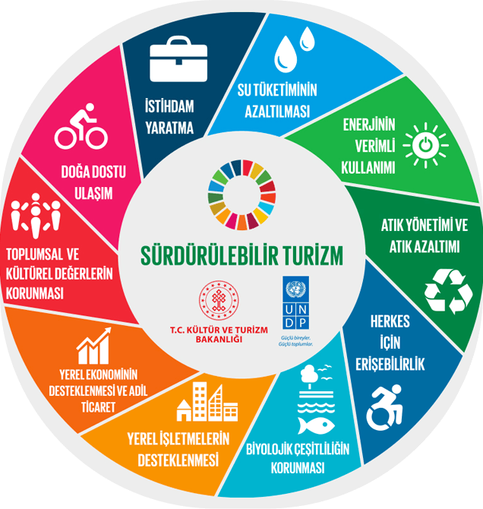
Figure 3.2.1: Sustainability Goals
  - Purchasing Management
We create our supply chain by basing our facility and purchasing processes on a sustainable and environmentally friendly perspective. This policy includes various sub-headings:
Legal Compliance: In all our purchases, we collaborate with reliable and ethical suppliers who fully comply with local and national legal regulations.
Environmental Impact Minimization: By making our purchases primarily from nearby regions, we minimize the CO2 emissions of supplier companies' delivery vehicles. With this approach, we reduce environmental impacts and support the local economy at the same time.
Energy Efficiency and Recyclable Products: We prefer products with high energy efficiency, certification, recycled content, and repairable products in the products we purchase. In this way, we promote environmentally friendly products. 15th
Certified and Eco-Friendly Products: We prefer products with certified recycled content among our suppliers. We adhere to sustainability principles by prioritizing environmentally friendly suppliers.
Sustainable Construction and Furniture: When choosing construction and furniture materials, we prefer recycled or refurbished, sustainably sourced, locally produced and environmentally certified products.
Sustainable Transportation Promotion: We encourage the purchase of vehicles with minimized environmental impact. In this way, we aim to contribute to sustainable transportation.
Threatened Species and Natural Resources: We strive not to use threatened species in our supply chain, not to hunt and to support sustainable resources.
Local Collaborations: To support employment growth, we prefer to collaborate with local suppliers when building our supply chain.
It aims to fulfill its environmental and social responsibilities in line with the sustainability mission of our business.

  - Environmental Management
As an environmentally friendly and environmentally friendly facility;

  - Waste Management
We manage our waste according to the Waste Management Hierarchy (Waste Pyramid).
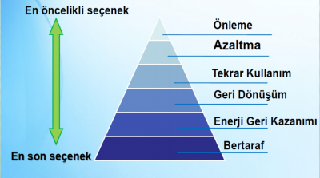
Figure 3.4.1: Waste Pyramid
Our waste reduction methods are determined and managed according to Waste Types. Details are in the Waste Management Plan.
Wastes are separated where they are generated. Wastes that cannot be separated are separated in Hazardous and Non-Hazardous Waste Temporary Storage Areas and sent for recycling. In the Waste Management Plan, the responsibilities of collecting and sending wastes are defined.

  - Energy Management
The energy manager's opinion for energy saving is taken at the time of purchase of electricity-consuming equipment.
• The electrical system in the rooms turns off when the card is deactivated.
• LED technology is used in all (80%) lighting throughout the hotel.
• There is a timed system in outdoor lighting according to daylight.
• Energy-saving comfort double glazing is available throughout the facility.
• There are energy-saving, inverter and new generation gas (R32) split air conditioners.
• Sensor lighting is used in the general area, common area, washbasin and corridors.
• The settings of the air conditioning devices in the rooms are made under the control of the technical service.
• Awareness is raised through sustainability, energy efficiency trainings and posters.
Electricity consumption is calculated and managed per guest. The follow-up of the targets and deviations are monitored by the management.

  - Water Management
The water problem is making itself felt more and more in social, economic and environmental areas on a global scale. According to the Risk Report prepared for the World Economic Forum, water scarcity is among the three most important risks in the world. This will affect not only water-stressed basins, but also many production processes. With the increasing volume of international trade, water is no longer considered a local but a global resource. Therefore, the sustainability of freshwater resources is critical not only for social and environmental aspects but also for the sustainability of the economy. In this context, when the Water Risk Map is examined, it is seen that the occupancy rate of dams has decreased due to climate change. Effective use of water is an important focus for us.
For this purpose, we take various measures within our hotel.
- It uses water-saving equipment in order to reduce general water consumption without compromising health, hygiene and guest satisfaction issues (aerator in Lobby, Kitchen, SPA and room sinks)
- We inform guests about water consumption and train our employees on this issue.
- In addition to low-flow special faucets and shower heads, we prevent unnecessary water use with the use of photocell or timed faucets. We reduce the use of siphon water through low-volume reservoirs. Water consumption in reservoirs in rooms is reduced by 50%. Siphons have a 2-stage mechanism.
- We train our staff to detect and prevent water leaks from room toilets, and we expect our guests to report these leaks to us.
- Towel and sheet changes in the rooms are carried out in line with guest requests and guests are informed about this. If the guest does not request, changes are made every two days.
In sinks; While 8 liters of water normally flows per minute, 3.5 liters when a regulator water flow regulator is used,
In the shower faucet; While 18 liters of water normally flows per minute, 9 liters when a regulator water flow regulator is used,
In the shower head; While 12 liters of water normally flows per minute, 8.5 liters of water is consumed when a regulator water flow regulator is used.
Water consumption is calculated per room/per stay. The follow-up of the goals is done by the management.

  - Chemical Management
An inventory has been created for the chemicals used. Care is taken to ensure that it is biodegradable in chemical supply. Documents related to this are obtained from the supplier company. MSDSs of chemicals are examined and kept in areas accessible to employees. Mixtures are carefully prepared for optimum chemical consumption. Mixture percentages are available in the inventory. There are special dosing mechanisms in the bottles. Employees are trained on the use of chemicals.
Our guests are informed about room cleaning and textile replacement in case of need.
Necessary precautions are taken in chemical storage areas. There are Chemical Storage Matrices and Chemical Usage Instructions.

  - Geographical Awareness
As a destination that hosts the unique natural and cultural heritage of the region, it has a special importance in geographical awareness studies. The peninsula's unique topography, Mediterranean climate, endemic vegetation, and coastal ecosystems present elements that need to be carefully considered in terms of sustainable tourism practices. In this context, it is a critical requirement for all stakeholders operating locally to act sensitively to the environmental carrying capacity of the region.
The local people's lifestyle, architectural texture, and traditional production practices are among the basic elements that shape their geographical identity. Therefore, preserving and sustaining region-specific values is a priority in sustainability practices. Local production and agro-tourism activities, especially in rural neighborhoods, both support economic development and increase geographical awareness.
Increasing construction pressure and tourism density create the need for strategic planning in terms of protecting natural resources. In this direction, region-specific solutions need to be developed on issues such as water resource management, coastline protection, biodiversity monitoring and waste management. Geographical awareness is not only the recognition of the natural environment, but also a sense of responsibility that ensures the sustainable management of this environment. We continue our activities with the awareness and awareness of all these.

  - Collaboration with Local Communities and Social Responsibility
Community/Locals:
- Our local people responsible has been determined. The Stakeholder Feedback Form is designed to manage the feedback to be received from the society.
- It is important to us that society is not adversely affected by our activities. We take the issue into account when conducting Environmental Dimension Impact Analysis.
- For us, society includes neighboring organizations.
- Our aim is to supply from the local people and to make our employees the people. These are monitored with performance indicators.
- In order to support the local right, information letters have been created for the guests, shopping areas/markets, etc. are promoted and directed.

  - Communication and Relations with Stakeholders
Our stakeholders:
- Our Board of Directors
- Our Employees
- Our Guests/Customers
- Community
- Our Suppliers/Contractors
- Other Facilities
- Official Institutions, Municipalities and Mukhtars, Non-Governmental Organizations

Our Guests:
Our guests are our reason for being. Our primary values are to follow up all guest complaints from all kinds of sources, to resolve complaints and to turn complaints into opportunities for ourselves by informing our guests about this issue. We receive and manage the feedback of our guests through our surveys in our rooms and with the Guest Satisfaction Survey Form created. By implementing our Corrective Actions, we aim to increase/ensure the continuity of our customer satisfaction. In this context, we have updated our survey and feedback forms to inform our guests about our sustainability efforts and to enable them to provide feedback in that area.
We also follow the feedback from the guests through the agencies.
We also record and evaluate our notifications from our staff with our Employee Feedback Forms and provide feedback.

Our Suppliers & Contractors:
- Our goal of integration and support with the community is to work with local suppliers. The products used in our open buffet and Ala carte Restaurant are procured from local farmers as much as possible and information is provided to the guests.
- Our local supplier ratio is monitored as a performance indicator. Our Supplier Selection and Evaluation criteria have been restructured by taking into account sustainability principles. Our aim is also the development of suppliers. All our suppliers have been informed about our sustainability journey.
- It is ensured that the products/services purchased are evaluated in this context, and documents touching the relevant areas are requested. (Example: Eco, FSC, ASC, MSC, ISO certificates)

Relationship with Official Institutions/NGOs:
- Relations with official institutions are in the dimension of declaration/audit and there is no problem with the continuation of documents at the facility.
- Relations with NGOs are developed by Facility Management. In this context, the names of some associations with which we are in contact/member are shared below.
No | Subject of the Activity | Studies Carried Out
1 | NGO membership | We are a member of BODER (Bodrum Touristic Hoteliers, Operators and Investors Association).
2 | To protect the soil, to prevent erosion and desertification. | We donate saplings to the TEMA Foundation.
3 | Protection of natural, historical and cultural assets | We make financial donations to ÇEKÜL (Foundation for the Protection and Promotion of Environmental and Cultural Values).
4 | Supporting education | We support donations to public schools in our region.
5 | Local Community Engagement and Support | We donate to the Red Crescent and YüCİTA and support local and social interactions.

  - Biodiversity and Natural Areas Protection
As an important part of the biogeography of the region, it contains a rich biodiversity. Endemic plant species, coastal and marine ecosystems, wetlands and maquis flora are the main factors that increase the ecological value of the region. This natural wealth is a strategic asset that needs to be protected not only for environmental but also for cultural and economic sustainability.
Increased tourism activities and urbanization pressure pose the risk of habitat fragmentation and a decrease in species diversity. Therefore, it is of great importance to develop conservation strategies based on cooperation between local governments, tourism enterprises and non-governmental organizations. Habitat monitoring studies carried out especially in less built-up areas such as Gölköy, Mazı and Karaova, and nature conservation projects carried out with the participation of local people are among the positive examples.
Among the activities carried out within the scope of biodiversity conservation, practices such as mapping seagrasses, monitoring caretta caretta nesting areas, supporting bee populations and protecting local seeds stand out. These efforts both ensure the continuity of ecosystem services and strengthen the connection of the local people with nature. The preservation of natural areas is made possible not only by physical boundaries but also by social awareness and participation.
We closely follow and support all these works carried out throughout the destination.

  - Wildlife Conservation and Support
It has a rich diversity of wildlife due to its location at the intersection of terrestrial and marine ecosystems. Sea turtles (Caretta caretta), Mediterranean monk seals (Monachus monachus) and various bird species observed especially on the coastline are among the main living groups that increase the ecological value of the region. The conservation of these species is not only environmental responsibility but also a fundamental component of the vision of sustainable tourism.
Among the efforts carried out to support wildlife, practices such as protecting nesting areas, reducing light pollution, controlling plastic waste that threatens marine life and ensuring the continuity of natural life corridors stand out. Monitoring and rehabilitation efforts, particularly in sensitive areas such as the Kudur Peninsula, Gölköy Lagoon, and Mazı surroundings, are carried out in collaboration with local NGOs and academic institutions.
Developing living practices that are compatible with wildlife is critical for the success of conservation efforts. In this context, it is recommended to give special place to wildlife elements in the environmental impact assessments of tourism facilities operating in this context, to make plans that will not harm natural habitats in construction processes, and to disseminate awareness-raising training programs. Wildlife conservation is a strategic investment not only for the continuity of existing species but also for the sustainability of ecosystem services. We support and share such investments for the protection of wildlife.
By following the endemic, local plant and local animal species living in the region, we aim to create activities that can be beneficial to biodiversity.
Some of the local endemic species are;
✔ Bodrum Mandalinası (Citrus Reticulata)
✔ Frenk İnciri (Opuntia Ficus-İndica)
✔ Zeytin (Olea Europaea)
✔ Karabaş Otu (Lavandula Stoechas)
✔ Deniz Börülcesi (Salicornia Europaea)
✔ Carob Tree (Ceratonia Siliqua)
✔ Kenger Otu (Gundelia Tournefortii)
✔ Isırgan Otu (Urtica Spp.)
✔ Yılan Dili (Arum Maculatum)
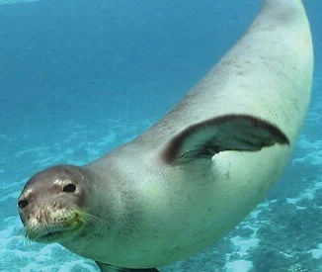
✔ Fox, Wild Asparagus (Asparagus acutifolius)
✔ Çeti (Latincesis Sarcopoteriumspinosum)
✔ Akdeniz Foku (Monachus Monachus)
✔ Sole (Solea Solea)
✔ Barbun Balığı (Mullus Barbatus)

  - Access for All
It is a dynamic tourist destination in the region, where individuals from different age groups, physical proficiency levels, and socioeconomic backgrounds coexist. This diversity makes improving access opportunities for all not only an ethical responsibility but also an essential component of sustainable development. Accessibility, beyond physical infrastructure, should be considered as the right to equal access to information, services and experiences.
In recent years, efforts to bring public spaces, coastal walkways, cultural facilities, and hospitality businesses into compliance with accessibility standards have gained momentum. Ramps, voice guidance systems, and accessible menus designed especially for wheelchair users, elderly individuals, and visually and hearing-impaired guests are among the concrete examples of inclusive tourism. These practices improve the quality of life for both locals and visitors.
The cooperation of local governments, the private sector and non-governmental organizations plays a critical role in improving access opportunities in the region. Accessibility audits, staff training, and improvement processes based on user feedback aim to make inclusivity a corporate culture. In addition, steps are taken regarding digital access, making websites, mobile applications, and digital content compliant with accessibility criteria. Access for all is a cornerstone of a vision for a future that aligns with the principles of social justice and equality.
We continue to make improvements in our facility for accessibility.

  - Personnel and Working Life
We care that all our employees work in a healthy, happy and safe work environment. We strive to ensure that the personnel we employ are from the people of the region. In this way, with the multiplier effect of the economy, we contribute to the revitalization of the economy in the region by the personnel we employ.
As a business that provides services at international standards that appeal to our guests from different countries and nationalities, discriminating against our guests and employees based on nationality, race, language, religion, etc. is against both our hotel management and our working principles.
It is our main principle to treat all our employees fairly, regardless of their sexual orientation, age, gender, ethnicity, religious belief or disability.
In this context;
✔ We adopt a common understanding that includes safe,equitable, fair and equitable conditions .
✔ We offer the opportunity to work in a standard, high-quality environment .
✔ We give priorityto listening to and solving problems.
✔ We implement a policy of working and remuneration that is fair, meets legal regulations and establishedstandards.
✔ We apply a messagemodel in which we listen to the moments, where ideas can be expressed, and dialogue is developed. (Except for the lines)
✔ It makes us feel that they are safe when they work , andwe protect their personal information.
✔ We are committed to the right to freedom of expression and expression.

- CULTURAL AND HISTORICAL HERITAGE
Bodrum, where everyone has a love in them, has been one of the most popular settlements in the Mediterranean from the time of myths to the present day. The town, which was first named "Halicarnassus", later started to be called "Bodrum" and was accepted as one of the leading cities of the region called "Caria". As we learn from the works of the famous historian Herodotus, the city was founded by the Lelegs in 2000 BC.
The most famous of Bodrum are; The Windmills and Bodrum Castle are the landmarks of the town and are among the most famous places to visit.
Museum card; With the museum card, you can visit many ancient sites and museums in the region, especially the Bodrum Museum of Underwater Archaeology, without paying an additional fee.

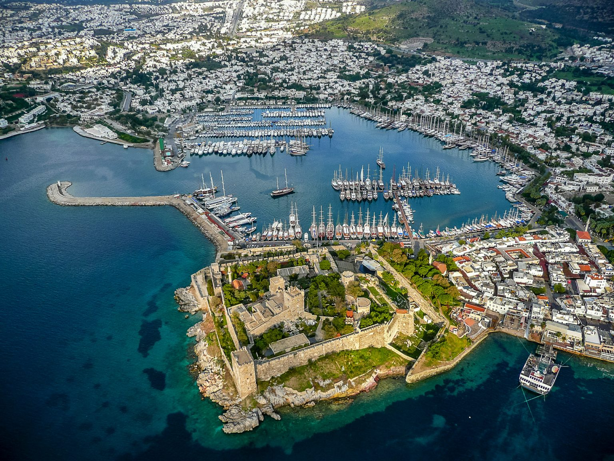
Bodrum

  - Bodrum Castle
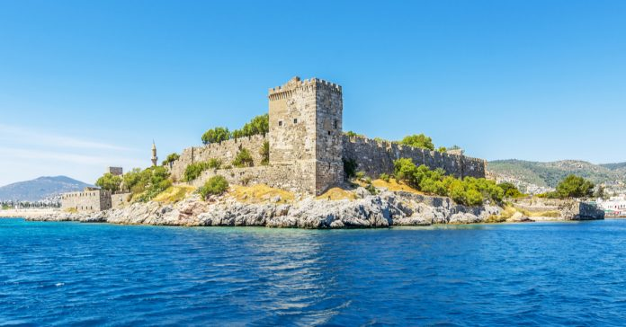
Bodrum Castle is a structure built between 1406 and 1522 and played important roles in the defense of Bodrum. The castle was built between two ports. Bodrum Castle, which has a square plan, measures 180×185 meters. The French Tower, which is considered the highest point of the castle, has a height of 47.5 meters.
Bodrum, where everyone has a love in them, has been one of the most popular settlements in the Mediterranean from the time of myths to the present day. The town, which was first named "Halicarnassus", later started to be called "Bodrum" and was accepted as one of the leading cities of the region called "Caria".
The most famous of Bodrum are; The Windmills and Bodrum Castle are the landmarks of the town and are among the most famous places to visit.
Bodrum Castle is one of the landmarks of Bodrum and the Underwater Archeology Museum within it allows us to count it among the most important touristic spots of Bodrum.
Address: Çarşı, Kale Cad. 48400 Bodrum/MUĞLA
Phone: 0 252 316 10 95
Visiting hours: April-October (summer period) 08.30-18.30, November-March (winter period) 08.30-16.30. Closed on Mondays during the winter months.
Distance to Property: 4 km

  - Bodrum Ancient Theater
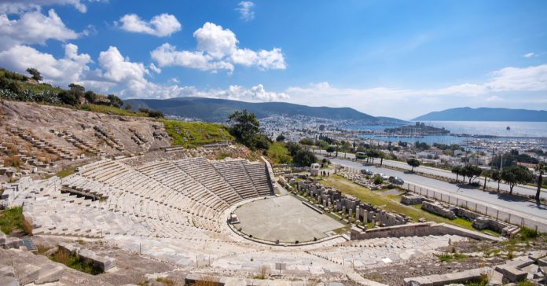
The history of Bodrum Ancient Theater, located on the southern slope of Göktepe, dates back to the IV century BC. This important building, where the theater history of the Roman Empire was written, is used as a concert venue today. The theater, which was restored in 1990, was offered to the public with its magnificent view. At the same time, the building, which is also the oldest ancient theater in Anatolia, is a must-see historical place.
This impressive art space still hosts various artistic activities today. Bodrum Antique Theater should definitely be on your list to watch an enjoyable event and feel the historical texture of the region better.
If you wish, you can plan by following the events here. By the way, we recommend that you bring a cushion with you, as the stone seats are a bit hot.
Address: Yeniköy, Bodrum, Muğla
Phone: 0 252 316 80 61
Visiting hours: 09.00-19.00 in summer and 08.00-17.00 in winter
Distance to Property: 4 km

  - Myndos Ancient City
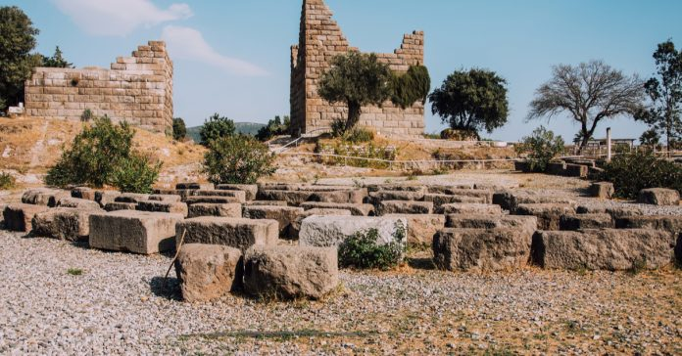
The source of ancient writings is the ancient city of Myndos in the town of Gümüşlük. It is located at the intersection of Mediterranean and Aegean cultures. Much of the city, which has a rich historical past, has been submerged.It is considered one of the 8 cities founded by the Lelegs in 640 BC. It is possible to observe the architectural ideas of different nations, and it is thought that many important ruins that have not yet been unearthed are waiting to be discovered underwater in the ancient city.
Myndos Ancient City is located at an easy, roadside point in terms of transportation. Since this is a very important visiting point to take magnificent photos, especially during sunrise and sunset, Myndos Ancient City is one of the places to visit for a trip to Bodrum.
Address: Gumusluk, Bodrum, Mugla
Visiting hours: All day long
Distance to Property: 22.3 km

  - Myndos Gate
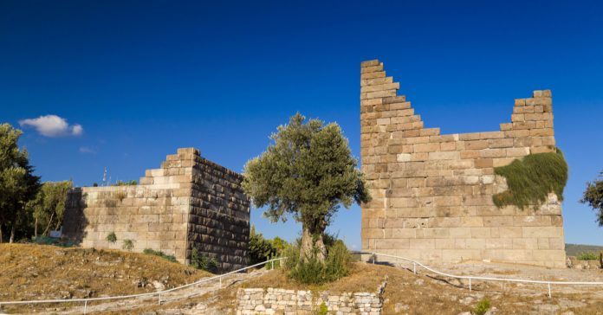
It is estimated that the Myndos Gate was built in 360 BC. The gate was built by Maussolos, the Satrap of Caria. It was called by the same name because it is located in the ancient city of Myndos. The gate, which has an impressive appearance, is among the important historical points of Bodrum. The building, which was built for defense purposes, formed a very important protection wall for Halicarnassus and fulfilled its duty properly. Even Alexander the Great, who wanted to capture the city, could not pass through this gate. Another gate built for the protection of the city, the Mylasa Gate, has disappeared.
Address: Eskiçeşme, Bodrum, Muğla
Visiting hours: All day long
Distance to Property: 2.3 km

  - Mausoleum at Halicarnassus
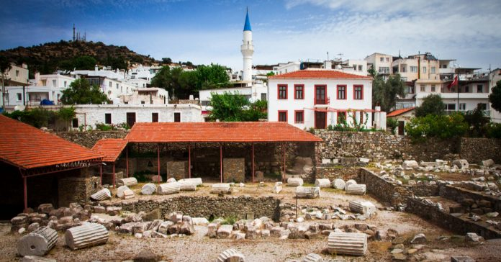
The Mausoleum at Halicarnassus is one of Bodrum's historical structures worth seeing. It was built in 353 BC on behalf of King Mausolus by his wife and sister and is also called the "Tomb of King Mausollos". It is a tomb monument that has been turned into a museum today. It is located very close to Bodrum Castle. The mausoleum represents both Greek and Egyptian architecture.
The stones of the Mausoleum at Halicarnassus were used during the construction of Bodrum Castle. It is assumed that the monument was destroyed as a result of an earthquake after standing for about 1500 years. The remaining pieces of the museum are exhibited in the British Museum.
Although not much remains of the Mausoleum of Halicarnassus, which is considered one of the 7 Wonders of the World, it is among the most important historical places that must be seen.
Address: Tepecik, Turgut Reis Cad. No:93, 48440 Bodrum/Muğla
Visiting hours: Summer period 08.30-18.30, Winter period 08.30-17.30
Distance to Property: 2.6 km

  - Karakaya Village
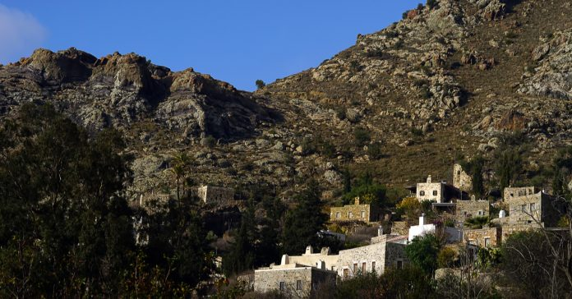
Karakaya Village has become one of the safe settlements in Bodrum, which is open to attacks from the sea due to its location. This place was established after the 14th century and is a very important treasure for Bodrum's history with its approach 700 years of history. The place where the village was founded has an altitude of 450 meters and the similar stone houses offer a magnificent view.
Karakaya Village is among the must-see historical places in Bodrum as it is one of the most beautiful examples of historical stone architecture in the region.
Karakaya Village is also known for its magnificent view of Gümüşlük Bay. For this reason, when you come to the village, you should definitely watch this exquisite view.
Address: Karakaya District, Bodrum, Muğla
Visiting hours: All day long
Distance to Property: 19 km

  - Dibeklihan Culture and Art Village
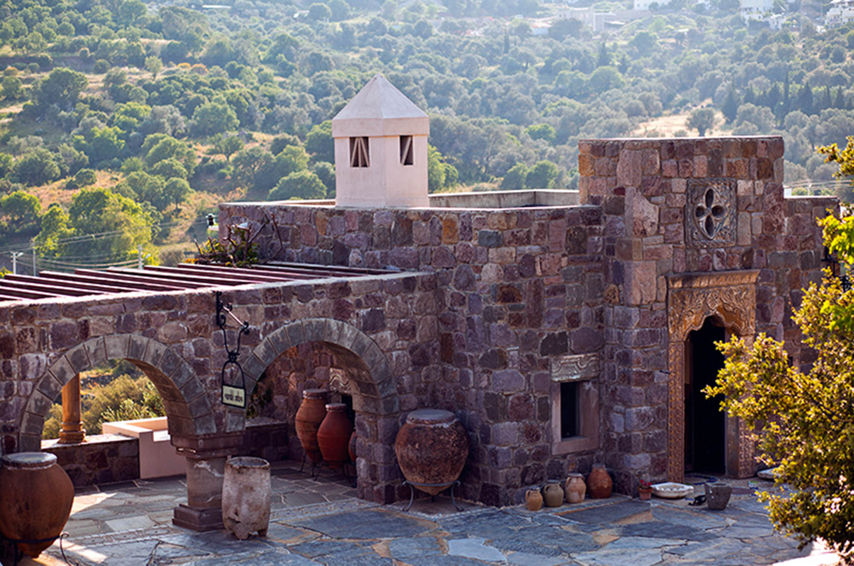
Dibeklihan Culture and Art Village, which has been in service since 2013, was opened for the accommodation of passengers and to meet their needs. Art Village, which is 13 km from the district center, is located within the borders of Bodrum Yakaköy. You can reach the village in about 20 minutes with your private car, or you can reach the village by using public transportation in the city center.
Inside the place, which has won the appreciation of its visitors due to its extraordinary architecture and location; There are design workshops, craft shops, an art gallery, restaurants and cafes.
Various artistic and cultural activities such as concerts and fashion shows are also held in the venue, where exhibitions such as sculptures, paintings, etc. are held, and film and dance performances are held.
In Dibeklihan Culture and Art Village, where invitation organizations such as engagements and weddings are held, especially in the summer months, various items used by the local people in daily life are exhibited in the "Chest Room" section, which is reserved as an exhibition area.
You can have pleasant moments with exhibitions, events and fun organizations held in Dibeklihan Culture and Art Village and have an unforgettable holiday experience.
Address: Yakaköy, Bodrum, Muğla
Visiting hours: Every day of the week except Monday 10:00 - 20:00
Distance to Property: 9 km

  - Windmills

Bodrum Windmills are among the historical symbols in Bodrum due to both their appearance and historical background. The mills are thought to have been built in the 18th century and there are 7 in total . Only one of the mills, which were used for a long time in accordance with their intended purpose, has survived to the present day, while the propellers of the others have been damaged.
Ground mills, which are one of the places that those who come to Bodrum do not return without seeing, are one of the most important places to go to take Bodrum souvenir photos.
Address: Dağbelen, Bodrum, Muğla
Visiting hours: All day long
Distance to Property: 11.4 km

  - Ottoman Shipyard
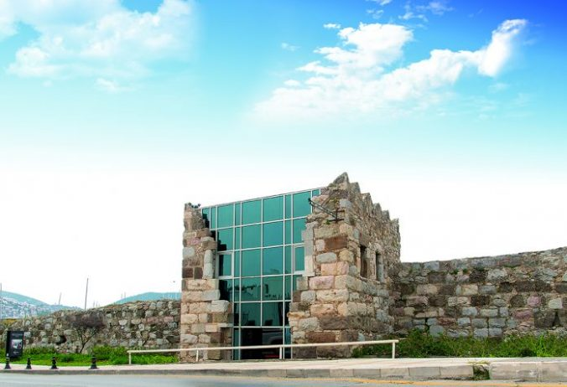
The shipyard, which dates back to the 1700s, now serves as an art gallery. There is an Ottoman Cemetery behind the building . New ships were built for the Ottoman Navy in the shipyard, which was one of the important structures of that period due to being a port city. Today, the restored Ottoman Shipyard is used for various exhibitions and art events.
There are tombs and tombs belonging to important maritime names of the Ottoman Empire in the shipyard. At the same time, the artistic activities carried out today make this place attractive.
We recommend that you do not miss the impressive marina view that you come across when you climb to the top of the shipyard.
Address: Eskiçeşme, Neyzen Tevfik Cad. No:5, 48400 Bodrum/Muğla
Visiting hours: All day long
Distance to Property: 2.7 km

  - Apostolic Church
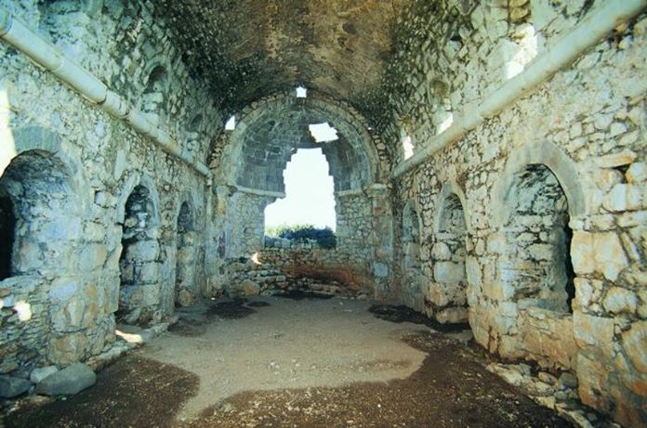
The Apostolic Church is located on Little Rabbit Island. It is estimated that it was built in the 2nd century BC. It is estimated that various additions were made to the church between the 6th and 12th centuries. The name of the island is also called "St. Apostol's Island" because of the church. It was built with similar features to the Hagia Sophia Mosque and is thought to have been built close to each other. While the church was being built, the basilica was built in a planned way. It was taken under protection by Italy and Turkey. It is a hidden treasure for history lovers.
The restoration works carried out by both Italy and Turkey since 1996 show us how important the church is for the world. For this very reason, we think that the Apostol Church should definitely be on a list of must-see historical places in Bodrum.
Since the place where the church is located also has a magnificent view, do not forget to enjoy this view.
Address: Göltürkbükü, Küçük Tavşan Island, Bodrum, Muğla
Visiting hours: All day long
Distance to Facility: 29 km

  - Zeki Müren Art Museum
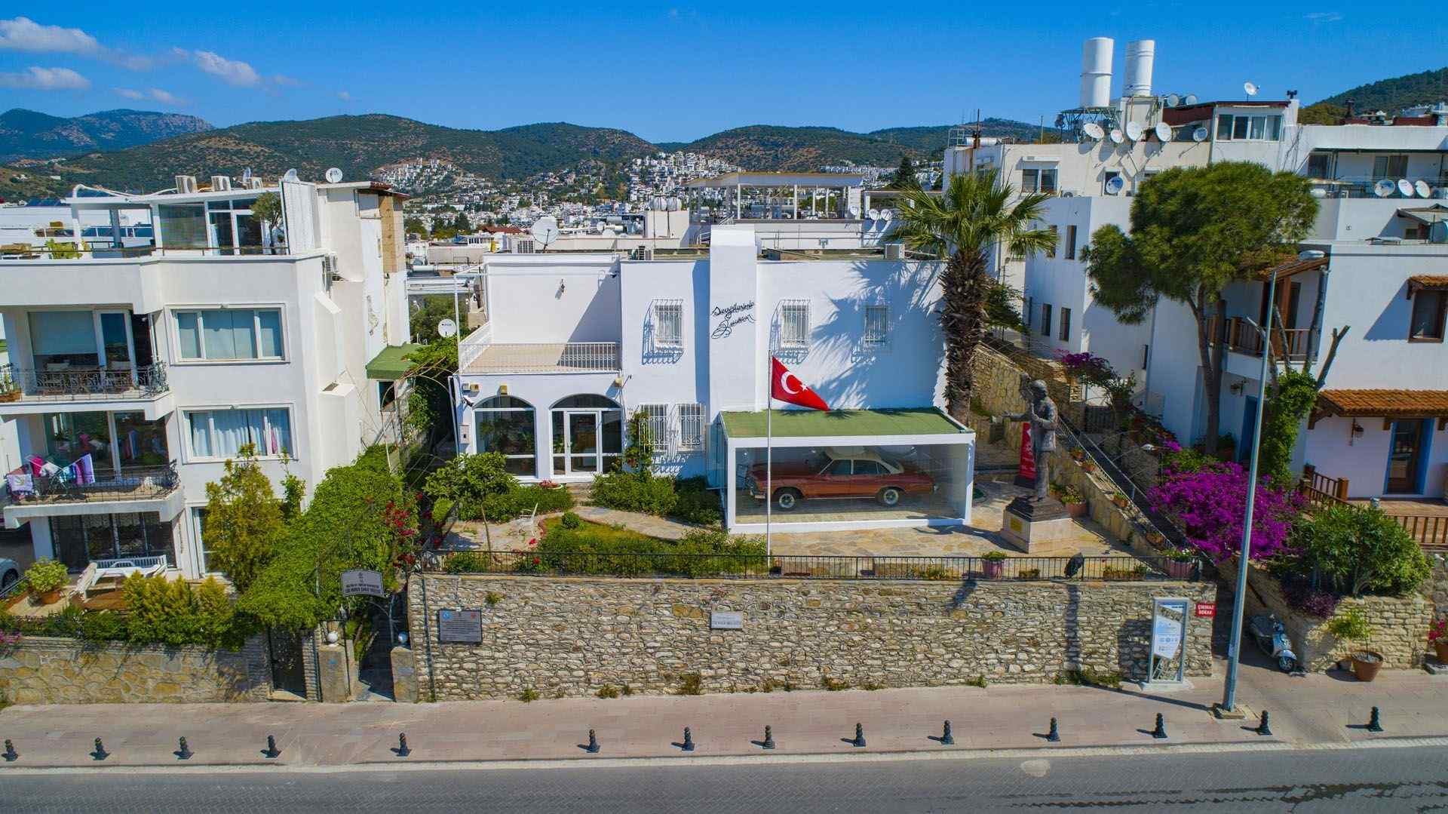
The museum, which is located in memory of Zeki Müren, the Sun of Art, in Bodrum, where he settled in 1980 and lived until his death in 1996, is a good opportunity to see many different details about the artist. The two-storey house where the artist lived was converted into a museum in 2000 and started to accept visitors. Important materials such as various documents, stage clothes and photographs about the artist can be seen in the museum.
To get important information about Zeki Muren, one of the most distinguished artists our country has raised, you should add the Zeki Müren Museum to your list of important places to see in Bodrum.
Address: Kumbahçe, Zeki Müren Cad. No:11 48400 Bodrum/MUĞLA
Phone: 0 252 313 19 39
Visiting hours: Tuesday-Sunday 08.30-17.00
Distance to Property: 6.1 km

Things to Consider When Visiting Areas and Museums Containing Religious, Cultural and Historical Buildings:
Museums; They are places that contain objects and stories belonging to the fields of culture, art, nature, science and technology. Learning is more relevant and exciting in the face of real objects in museums, and effective learning takes place. One of the most important duties of museums is to educate and inform people.
- The warnings made in the museum should be taken into account.
- The warnings of the staff and the visiting rules hanging in the museum should be followed.
- At the entrances, if necessary, an ID-museum card must be presented and ticketed entry must be made.
- When visiting the museum, you should be quiet and not make noise.
- The works exhibited in the museum and their safes (pedestals) should not be touched, written on them (this warning should be made especially when going to open-air museums and ruins), the items should not be damaged, the whole or any part of the items/artifacts should not be removed from the area, and the artifacts should not be damaged.
- Attention should be paid to the warnings in the museum that you can/do not take photos.
- Attention should be paid to the warnings in the museum visited that you can/do not take flash shots.
- What is said should be listened to carefully, and questions should be asked to guides and museum education experts (if any).
- The officer whose information we consulted about the works should be thanked.
- Museums should not be entered with food and drink.
- Ancient city areas should not be destroyed, areas under protection should not be entered and their surroundings should not be polluted.
- Picnics should not be made in natural sightseeing areas and forests, fires should not be lit, garbage should not be thrown on the ground and warning signs should be observed.
- On group trips, they should not be separated from the group. If you think you are separated from the group or lost, you should ask the staff for help and go to counsel.
- Disturbing behavior should be avoided during the trip. Inappropriate intimacy should not be established with adults and children and people should not be disturbed.
- The purchase and sale of historical artifacts should not be done without the necessary permits and documents. Illegal trading should not be done.
In the visits of collective places of worship (mosques, churches, synagogues, etc.), which are referred to as Faith Tourism; The place of worship to be visited should be visited in accordance with the religious issues and should be visited with tolerance.
- The warnings made by the officers at the entrances should be taken into consideration,
- If necessary, appropriate clothing should be worn in the entrance areas, shoes should be removed when visiting mosques, and women should use headscarves,
- Worshippers should not be disturbed in the visiting areas, they should be quiet and no noise should be made,
- Attention should be paid to issues such as not entering with food and drink, and not throwing garbage on the ground.

Points to be Considered in Natural Area Trips and Visits:
- Warnings made by the staff should be taken into account at the entrances,
- Fires should not be lit in wooded areas,
- Garbage and especially glass and cigarette butts should not be thrown on the floor,
- Prohibited areas such as "No Entry" and "No Swimming" should never be entered,
- The habitats of all living things such as plants and animals living in nature should not be harmed.
Wildlife Conservation and Points to Consider in Trips:

- While walking in nature, one should not talk loudly, listen to loud music and break the natural silence. This behavior is vital for birds and other creatures.
- While feeding wild animals may seem like good behavior, it disrupts their natural behaviors and feeding habits. Creatures encountered in their natural environment should not be loved, given food and harmed.
- Garbage should not be left in natural areas, cigarette butts should not be thrown and campfires should not be lit. Adopt the principle of "take back what you bring".
- In order to prevent endemic or sensitive species from being harmed, flowers should not be plucked, animals should not be handled, and their natural habitats should not be interfered with.
- When watching wildlife, remote observation should be done and shooting should be done without flash. Their boundaries should be respected so that animals do not get stressed.
- If you have pets, they should be walked on a leash and kept under control on nature walks. Keep in mind that they can pose a threat to wild animals.
- Hunting should be done in accordance with the laws and rules determined for hunting. Wildlife and natural life should be respected.
- In order to protect biodiversity, products belonging to endangered creatures should not be purchased.
In addition; You can find Bodrum Destinations and details prepared by the Ministry of Culture and Tourism of the Republic of Turkey at https://bodrum.goturkiye.com.

- OUR POLICIES
Our organization has a structure that integrates the sustainability vision into all its operational processes and acts in line with environmental, social and governance (ESG) principles. The corporate approaches under the heading of "Our Policies" not only ensure legal compliance but also reflect our ethical responsibilities, stakeholder expectations, and our goal of creating long-term value.
All our policy documents; It is prepared with the principles of transparency, accountability, inclusiveness and continuous improvement and is regularly updated. In this context, we have corporate policies in key areas such as environmental management, energy efficiency, water and waste management, human rights, occupational health and safety, local development, protection of cultural heritage, ethical supply chain and guest satisfaction.
Our policies do not only regulate internal processes; it also drives our interaction with our employees, suppliers, guests and local communities. Each policy is structured in accordance with relevant national legislation and international standards (e.g. ISO 14001, ISO 9001, ISO 26000, GSTC, GRI). In this way, our sustainability performance becomes traceable, evaluative and improveable.

  - Sustainability Policy
1. Purpose
Our facility is committed to carrying out its activities based on environmental, social and economic sustainability. This policy aims to support cultural heritage by using natural resources effectively, environmentally friendly practices, protecting employee and public health.

2. Our Principles
- Environmental Management:
  - Reduce resource consumption
  - Separating waste at source
  - Disposing of hazardous waste without harming the environment
  - To be fully compliant with relevant laws and regulations
- Education and Awareness:
  - To provide regular environmental and occupational health trainings to employees
  - To increase environmental awareness in society
  - To spread preventive culture through trainings
- Occupational Health and Safety:
  - To provide a safe and healthy working environment
  - Preventing work accidents by identifying risks in advance
  - To adopt an approach that respects human rights and is free from discrimination
- Social Responsibility:
  - To increase local employment and improve the quality of service
  - Contributing to the protection of vulnerable groups
  - To provide social and economic benefits to the people of the region
- Accessibility:
  - Providing accessible tourism services for all
  - Transparently sharing accessibility
- Preserving Cultural Heritage:
  - Not to harm cultural values
  - Contributing to local culture
- Purchase Policy:
  - Purchasing locally, environmentally consciously and based on fair trade
  - Auditing suppliers' sustainability processes
- Guest Satisfaction:
  - Analyzing guest expectations in advance
  - Using transparent and realistic promotional materials
  - Providing accurate information across all communication channels
- Transparency and Public Information:
  - Sharing activities with the public
  - To announce measures to protect natural life

  - Quality Policy
1. Purpose
Our main goal is to establish, implement and continuously improve the quality management system of our facility in accordance with international standards. Keeping guest satisfaction at the highest level, making a difference with exemplary practices that shape the sector, and integrating the understanding of "superior quality" into all our processes form the basis of this policy.

2. Our Principles
- Quality Management:
  - System installation and implementation in accordance with ISO 9001 standard
  - Continuous measurement and improvement approach
  - Immediate detection and correction of errors
- Management Approach:
  - Open and transparent management
  - Principles of professionalism, honesty, reliability and diligence
  - Full compliance with brand standards
- Employee Development:
  - Continuous education and awareness raising
  - Occupational safety and food safety-oriented practices
  - Correct, safe and conscious working culture
- Technology and Investment:
  - Investment planning in line with guest expectations
  - Integration of current technologies
  - Efficient use of knowledge and experience
- Competition and Leadership:
  - Active competition in the national and international market
  - Maintaining a leading position in the sector
  - Service approach that does not compromise on quality

  - Purchasing and Local Supplier Policy
1. Purpose
This policy has been prepared to reduce environmental impacts, support local development, and adopt an ethical, fair, and responsible approach to procurement processes in line with sustainability principles.

2. Our Principles
- Environmental Sensitivity:
  - Preferring products that consume less energy and water
  - Selecting equipment and services that reduce waste generation
  - Use of materials that cause the least harm to the environment
  - Renewal of cooling systems in accordance with environmental legislation
- Sustainable Supply:
  - Purchase of environmentally certified products from local producers
  - Selection of products that are sensitive to animal rights and wildlife protection
  - When certified products are not available, research of production methods
- Waste Management:
  - Careful management of food and consumables
  - Prioritization of recyclable, returnable products
  - Auditing suppliers' waste management processes
- Yerel Kalkınma:
  - Buying from local businesses
  - Supporting the sustainable product development processes of local entrepreneurs
- Ethics and Fair Trade:
  - Avoiding corruption, bribery and conflicts of interest
  - Compliance with commercial ethics and legal regulations
  - Protection of intellectual property rights
- Social Responsibility:
  - Prioritizing human rights, occupational safety and environmental awareness in the supply chain
  - Establishing trust-based business relationships with local/regional suppliers
  - Promoting open, equal and fair trade

  - Environment and Waste Management Policy
1. Purpose
Our facility acts with a sense of responsibility towards the environment and society. We carry out our activities with a sustainable environmental approach, committing to minimizing environmental impacts, using natural resources effectively, and preventing food waste.

2. Our Principles
- Legal Compliance and Use of Technology
  - Full compliance with environmental legislation and administrative regulations is ensured.
  - Technologies that cause the least harm to the environment are preferred in activities.
- Environmental Awareness and Education
  - Regular environmental training is given to employees.
  - Environmental awareness is shared with guests, suppliers and the community.
- Waste Management
  - Wastes are reduced, separated and recycled at the source.
  - Hazardous wastes are disposed of in accordance with the legislation.
  - Wastes are stored in separate areas according to their characteristics and delivered to licensed companies.
- Preventing Food Waste
  - Procedures are applied to reduce food waste in production, service and consumption processes.
  - Local collaborations and donation mechanisms are developed for the safe use of surplus food.
  - Unnecessary food consumption is prevented through quantity planning, portion control, and stock management.
  - Food waste data is monitored, analyzed, and remediation efforts are carried out.
- Conservation of Natural Resources
  - Water and electricity consumption is monitored regularly.
  - Unnecessary resource use is prevented and protective measures are taken.
  - Biological control and drip irrigation methods are applied in garden maintenance.
- Reducing Chemical Use
  - Chemicals are used in sufficient amounts and in a controlled manner.
  - Excessive chemical consumption is prevented, and personnel are trained on this issue.
- Emergency Management
  - Response teams are formed against environmental emergencies.
  - The level of readiness is increased by regular drills.
- Continuous Improvement and Performance Monitoring
  - The environmental management system is regularly reviewed.
  - Performance data is tracked, compared to targets, and improved.
- Carbon Footprint and Greenhouse Gas Reduction
  - Carbon emissions and greenhouse gas effects are tried to be reduced.
  - Announcements and information boards are used to increase environmental awareness.

  - Human Rights, Employee Rights and Equal Opportunity Policy
1. Purpose
This policy aims to provide a fair, safe and respectful working environment for all employees; It aims to create a corporate culture based on equal opportunities, free from discrimination.

2. Our Principles
- Prevention of Discrimination:
  - In recruitment, promotion, training, remuneration and termination processes; There is no discrimination based on race, religion, sex, age, disability, sexual orientation, political opinion or union membership.
  - Women's participation in the workforce is supported, equal opportunities are offered in all departments.
- Working Conditions and Well-being:
  - Clean shower areas, drinking water, food, transportation and lodging facilities are provided to employees.
  - Physical, mental or verbal violence is not acceptable.
  - With an open-door policy, employees are encouraged to express their wishes and suggestions freely.
- Respect for Human Rights:
  - All employees' personal information is kept confidential.
  - The sense of belonging is strengthened and team spirit is supported.
  - Overtime is paid with wages; Annual leave rights are used on time.
- Training and Development:
  - Evaluation is made based on professional competence and experience, no age restriction is applied.
  - A common management language and learning culture are developed through continuous training.
  - Career planning is supported.
- Occupational Health and Safety:
  - Risks are identified in advance, occupational accidents and occupational diseases are tried to be prevented.
  - A safe and healthy working environment is provided, and employees are made aware of this issue.
- Fair Remuneration and Social Benefits:
  - A wage policy is applied in accordance with legal regulations and sectoral standards.
  - All employees benefit equally from social rights and the reward system.

  - Vulnerable Groups and Children's Rights Policy
1. Purpose
This policy aims to protect the rights of children and vulnerable individuals, keep them free from all forms of abuse and discrimination, and create a safe and respectful environment within the organization.

2. Our Principles
- Protection of Children's Rights:
  - Children are recognized as individuals; their rights are respected.
  - Protection is provided against all kinds of physical, psychological, commercial and social abuse.
  - Child labor is not employed; The same sensitivity is expected from business partners.
  - Adult supervision is provided at all activities attended by children.
  - Regular training is provided to employees on preventing and recognizing child abuse.
- Supporting Vulnerable Groups:
  - The rights of vulnerable groups such as women, the elderly, the disabled, pregnant individuals, those with mental disorders, ethnic minorities, refugees and the sick are respected.
  - These individuals are not allowed to be subjected to abuse, harassment, discrimination, coercion or exclusion.
  - The confidentiality of personal data is protected; consensual communication is taken as basis.
- Awareness and Education:
  - Trainings are organized to raise awareness about children's rights and the protection of vulnerable groups.
  - Active support is given to relevant social responsibility projects.
  - Suspicious situations are reported to the facility management; if necessary, official institutions are contacted.
- Creating a Safe Environment:
  - Environments are provided where children can express themselves freely and support their development.
  - All employees are responsible for maintaining this environment.

  - Customer Satisfaction Policy
1. Purpose
This policy aims to maximize customer satisfaction in the services offered by our facility, meet guest expectations and increase service quality with an understanding of continuous improvement.

2. Our Principles
- Guest Focus:
  - Our guests are our reason for being.
  - All service processes are designed based on guest satisfaction.
  - Guest feedback is considered as an opportunity for improvement.
- Complaint Management:
  - Guest complaints are recorded and resolved quickly and effectively.
  - The guest is regularly informed about the process.
  - Complaints are turned into opportunities through corrective and preventive actions.
- Expectation Analysis and Improvement:
  - Guest expectations are analyzed regularly.
  - Service quality is constantly improved according to these analyses.
  - All employees are actively involved in this process.
- Education and Awareness:
  - Employees are provided with a customer satisfaction-oriented service approach.
  - Through training, skills in communicating correctly with the guest are developed.
  - The understanding of quality spreads to the entire staff.
- Competition and Brand Power:
  - Guest satisfaction is the foundation of our competitiveness.
  - Satisfaction data is monitored to strengthen our position in the market.
  - Brand reputation is directly linked to the guest experience.

  - Occupational Health and Safety Policy
1. Purpose
Our facility adopts protecting the health and safety of employees as a main priority. This policy aims to create safe working environments, prevent risks and disseminate occupational health & safety culture at the corporate level.

2. Our Principles
- Human-Centered Approach:
  - Our employees are our most valuable asset.
  - Human health and well-being are prioritized in all activities.
- Risk Management and Preventive Measures:
  - Hazards and risks are identified and eliminated at the source.
  - Occupational accidents and occupational diseases are tried to be prevented with protective measures.
  - Each department regularly analyzes the risks in its field of activity.
- Legal Compliance and Continuous Improvement:
  - Full compliance with national legislation and international standards is ensured.
  - Occupational health and safety performance is regularly monitored and improved.
  - Goals are set and the system is improved with periodic reviews.
- Employee Engagement and Awareness:
  - All employees and their representatives actively participate in the process.
  - Opinions and suggestions are evaluated and turned into opportunities for improvement.
  - Awareness is raised through training, and safe behaviors are encouraged.
- Emergency Preparedness:
  - Emergency plans are created and tested through regular drills.
  - Response teams are determined and necessary equipment is kept ready.
- Communication and Transparency:
  - Information about occupational health and safety is shared openly.
  - Effective communication is established with all stakeholders.

  - Energy Management Policy
1. Purpose
This policy aims to minimize environmental impacts through the efficient use of energy resources, reducing consumption, and continuously improving energy performance.

2. Our Principles
- Legal Compliance and Standards:
  - Compliance with national and international energy management standards is ensured.
  - Legislation and regulations are regularly followed.
- Energy Efficiency and Performance:
  - Energy consumption is monitored, analyzed and mitigation measures are implemented.
  - Energy performance indicators are determined and compared with annual targets.
- Education and Awareness:
  - All employees are provided with regular training on energy efficiency.
  - Awareness activities are carried out with guests, visitors and business partners.
- Technology and Hardware Selection:
  - Energy-efficient products, equipment and systems are preferred.
  - In new investments, the energy consumption criterion is included in the evaluation process.
- Energy Management System (EnYS):
  - The system is documented, spread to all departments and reviewed regularly.
  - System performance is increased with a continuous improvement approach.
- Collaboration and Stakeholder Engagement:
  - Common energy targets are set with all stakeholders.
  - Employee participation in energy management processes is encouraged.
- Emergency Preparedness:
  - Preventive plans are prepared against energy constraints and risks.
  - Alternative energy sources are evaluated for critical systems.

  - Stakeholder Communication Policy
1. Purpose
This policy has been prepared to ensure that our facility establishes open, transparent, trust-based and sustainable communication with all its stakeholders. Our main goal is to systematically collect, evaluate and integrate stakeholder feedback into improvement processes.

2. Our Principles
- Transparent Information:
  - Our facility provides accurate, clear, and up-to-date information about its products and services.
  - Real images and content are used in promotional materials.
  - Sustainability performance is shared with the public through the website, social media and printed publications.
- Feedback Management:
  - Feedback from customers, employees, public institutions, local people and other stakeholders is recorded.
  - Negative feedback is analyzed, responded to, and necessary corrective actions are taken.
  - The feedback system is structured to be quick, accessible, and user-friendly.
- Employee Engagement and Debriefing:
  - Regular training is provided to employees on management systems and sustainability practices.
  - Duties and responsibilities are defined and communicated in writing.
  - Trainings are recorded, employees play an active role in the development of the system.
- Continuous Improvement:
  - The system is reviewed in line with the feedback from the stakeholders.
  - Communication processes are regularly evaluated and improved.
  - It is aimed to establish long-term relationships based on trust with all stakeholders.

  - Restricted Individuals and Accessibility Policy
1. Purpose
This policy aims to ensure accessibility standards and provide inclusive services for all guests, especially individuals with physical, visual, auditory, or mental disabilities.

2. Our Principles
- Accessibility Standards:
  - Accessibility infrastructure throughout the facility is established in accordance with legal regulations.
  - Accommodation, transportation, guidance and emergency systems are made suitable for the use of disabled individuals.
  - Special solutions are developed for individuals with vision, hearing and movement limitations.
- Continuous Improvement:
  - Accessibility infrastructure is regularly maintained and repaired.
  - Physical and digital access systems are updated in line with feedback.
  - New technologies and applications are followed and integrated throughout the facility.
- Disclosure and Transparency:
  - The accessibility level of the facility is shared clearly and accurately on the website and other communication channels.
  - Guests are informed about access facilities before booking.
- Employee Training and Awareness:
  - All employees receive regular training on accessibility, communication with individuals with disabilities, and inclusive service delivery.
  - The staff is responsible for providing services in a way that is sensitive and supportive to the needs of disabled guests.
- Inclusive Service Approach:
  - It is ensured that disabled individuals receive service in the same environment and under equal conditions with everyone else.
  - Discrimination, exclusion or restriction of service is not allowed at all.
  - A culture of barrier-free living is encouraged throughout the facility.

  - Food Safety Policy
1. Purpose
This policy has been prepared to ensure food safety in all processes of the facility, protect human health and maximize guest satisfaction. Our main goal is to provide safe, hygienic and compliant food at every stage of the supply chain.

2. Our Principles
- Food Safety Management:
  - Hygiene rules are fully applied at all stages from raw materials to consumption.
  - The Food Safety Management System (FSMS) is documented, disseminated to all employees and continuously improved.
  - Risks are assessed periodically, preventive measures are taken.
- Legal Compliance and Standards:
  - Full compliance with national and international food safety legislation is ensured.
  - Audit results are monitored and nonconformities are quickly eliminated.
- Supplier Collaboration:
  - Trust-based cooperation is established with suppliers.
  - Product safety and quality criteria are shared with suppliers.
  - Food safety experiences are mutually transferred.
- Education and Awareness:
  - All employees are provided with regular training on food safety.
  - Through trainings, the system is internalized and awareness is raised.
  - Critical issues such as hygiene, cross-contamination, temperature control are emphasized.
- Continuity and Improvement:
  - Food safety performance is regularly monitored.
  - Processes are developed in line with feedback.
  - Stability in service quality is ensured.

  - Local Community Support Policy
1. Purpose
This policy aims to contribute to the social and economic development of the local people in the region where our facility is located, to protect local resources and to support sustainable development.

2. Our Principles
- Promotion of Local Employment:
  - Care is taken to select the personnel employed in our facility from the local people as much as possible.
  - Training and skill development activities are supported for the development of the local workforce.
- Local Sourcing and Entrepreneurship:
  - Raw materials and services are primarily sourced from local suppliers.
  - Support is provided to the product and service development processes of local entrepreneurs.
  - Long-term collaborations are established with local producers.
- Collaboration with Civil Society:
  - Joint projects are carried out with non-governmental organizations operating in the region.
  - The participation of local stakeholders in social responsibility activities is encouraged.
- Conservation of Cultural and Natural Resources:
  - Activities for the protection of local cultural heritage are supported.
  - Sustainable use of natural resources is observed.
- Transparency and Engagement:
  - The opinions and suggestions of the local people are regularly received.
  - The effects of facility activities on the local community are openly shared.

  - Destination Participation Policy
1. Purpose
This policy aims to contribute to the cultural, natural and social values of the destination where our facility is located; It aims to support sustainable tourism development in cooperation with the local people.

2. Our Principles
- Preserving Cultural and Natural Heritage:
  - Through public and private sector projects, active support is provided to the cultural heritage and natural assets of the region.
  - Turkish culture, traditions and historical values are respected; The basic principle is to preserve this heritage and pass it on to future generations.
- Contribution to Local Economy:
  - The promotion and sale of artworks and handcrafted products produced by local people are encouraged.
  - Direct visitors to local products directly contribute to the regional economy.
- Visitor Awareness:
  - Guests are informed about the cultural values and local sensitivities of the destination.
  - Awareness is raised about the appropriate behavior for the region.
- Cooperation with Local Governments:
  - The active participation of local governments in the planning, management and development processes of tourism is supported.
  - Contributions are made to projects aimed at protecting the environmental, physical and visual quality of urban and rural areas.
- Environmental Responsibility:
  - Measures to prevent environmental deterioration that may occur in the destination are supported.
  - Facility activities are carried out in an environmentally friendly manner.

  - Policy on the Protection and Presentation of Cultural Heritage
1. Purpose
This policy aims to protect and promote the historical, cultural and social values of the region where our facility is located and to contribute to the transfer of this heritage to future generations.

2. Our Principles
- Cultural Information and Promotion:
  - Guests can be informed about the area's historical sites, heritage sites, and traditions through reception and sales points.
  - Visual materials, brochures and digital content are used within the facility to promote cultural heritage.
- Behavioral Guidance:
  - Guests are informed about appropriate behavior in cultural areas.
  - A respectful and sensitive approach to interacting with locals is encouraged.
- Preservation and Participation:
  - Cooperation is made with local governments to protect natural texture, historical structures, archaeological sites and cultural values.
  - Local sensitivities and the needs of the people are taken into account in the decisions to be taken.
- Cultural Inclusion and Equity:
  - Local people's access to cultural heritage is not prevented; all rights are respected.
  - There is no discrimination against differences such as ethnicity, belief or opinion.
- Supporting Local Culture:
  - Traditional dishes, handicrafts, and cultural events of the region are introduced to guests.
  - Guidance is provided in cultural interactions; keeping local values alive is encouraged.

  - Biodiversity Conservation Policy
1. Purpose
This policy aims to protect natural life in the regions where our facility is located, ensure the sustainability of ecosystems and support the continuity of biodiversity.

2. Our Principles
- Maintaining Ecosystem Balance:
  - Natural ecological balance is observed during facility activities.
  - The protection of local flora and fauna species is considered as a priority.
- Monitoring Invasive Species:
  - The presence of invasive species in the vicinity of the plant is regularly monitored.
  - Preventive measures are taken so that the habitat of local species is not disturbed.
- Enhancing Natural Habitats:
  - The rehabilitation of natural areas around the facility is supported.
  - Increasing green spaces and preserving natural vegetation are encouraged.
- Reduced Environmental Impact:
  - The impact of activities on the environment is regularly analyzed.
  - Impacts such as carbon footprint and habitat degradation are minimized.
- Collaboration with Stakeholders:
  - Joint projects are carried out with local governments, NGOs and academic institutions.
  - Activities are organized to raise awareness in the society about biodiversity.
- Education and Awareness:
  - Employees and guests are trained on biodiversity.
  - Awareness is raised with informative materials within the facility.

  - Wildlife and Animal Health Protection Policy
1. Purpose
This policy aims to protect wildlife, observe animal welfare and ensure full compliance with relevant legal regulations in the operating areas of our facility. Ethical, scientific and sustainable approaches are adopted in interaction with natural life.

2. Our Principles
- Legal Compliance and Scientific Approach:
  - Local, national, and international laws and guidelines are followed in wildlife interactions.
  - Action is taken in line with the opinions of wildlife experts.
  - Direct interaction (especially feeding) is carried out only if it is scientifically confirmed and there is expert advice.
- Mitigating and Monitoring Impact:
  - Disturbance to wildlife is minimized.
  - The effects of interactions on animal welfare are regularly monitored and evaluated.
  - Sustainability is ensured by establishing observation and reporting systems.
- Captive Wildlife and Collaboration:
  - Full compliance with laws and regulations regarding wild animals in captivity is ensured.
  - Conservation activities are carried out in cooperation with public institutions and non-governmental organizations.
- Pet Welfare:
  - The accommodation, feeding and treatment conditions of pets on site are regularly inspected.
  - Care, cleaning and veterinary services for animal health are provided completely.
- Education and Awareness:
  - Employees and guests are trained on wildlife and animal welfare.
  - Awareness is raised with informative materials within the facility.

  - Local Employment Protection Policy
1. Purpose
This policy aims to contribute to social development, increase economic opportunities and adopt an egalitarian approach to employment by supporting the local workforce in the regions where our facility operates.

2. Scope
All recruitment, training, development and procurement processes are evaluated within the scope of this policy. All departments and employees of the facility are obliged to act in accordance with these principles.

3. Our Principles
- Priority for Local Workforce:
  - Vacancies are first announced regionally.
  - Priority is given to local candidates; the participation of the people of the region in employment is encouraged.
- Training and Development Support:
  - Training programs are organized to support the professional development of the local people.
  - An advantage is provided in recruitment through skill acquisition activities.
- Equal Opportunity:
  - Equal opportunities are offered regardless of gender, age, ethnicity, creed or disability.
  - Merit and suitability are taken as basis.
- Local Supply Chain Collaboration:
  - Work with local suppliers whenever possible.
  - The development of local businesses is supported.

4. Responsibilities
- Management: Ensures policy implementation and realization of local employment targets.
- HR Department: Carries out recruitment processes and plans trainings for local candidates.
- All Employees: Acts sensitively to the importance of local employment and contributes to the process.

5. Tracking and Reporting
- Local employment rates are analyzed annually.
- The management evaluates the implementation with performance reports and plans the necessary improvements.

  - Local Awareness Policy
1. Purpose
This policy aims to increase sensitivity to the cultural, environmental and economic values of the region where our facility operates; It aims to contribute to regional development by working in harmony with the local people.

2. Our Principles
- Respect and Support for Local Culture:
  - Local arts, crafts and cultural events are promoted and supported.
  - Guests are offered local cuisine and traditional recipes.
  - Local manufacturers are prioritized in the supply chain.
- Environmental Sensitivity:
  - The conservation and sustainable use of the region's natural resources are encouraged.
  - Local people and guests are informed about waste management, energy conservation and environmental awareness.
- Contribution to Local Economy:
  - Local people's access to employment opportunities is supported.
  - The use of products and services produced in the region within the facility is prioritized.
- Social Responsibility:
  - Active participation is ensured in projects that will improve the quality of life of the local people.
  - Training and awareness activities are carried out in cooperation with local schools and institutions.
- Guest Participation:
  - Guests are informed about local attractions and events.
  - They are included in programs that contribute to the preservation of natural and cultural heritage.
- Continuity and Evaluation:
  - Policy implementations are regularly reviewed and improved.
  - Effectiveness evaluations are carried out in cooperation with local communities.
- Transparency and Accessibility:
  - The text of the policy is open to employees, guests and the public.
  - It has been made accessible by publishing on the facility's website.

  - Water Conservation Policy
1. Purpose
This policy aims to ensure the efficient use of water resources, prevent waste, and implement sustainable water management practices in our facility. Water conservation is a fundamental part of our environmental responsibility.

2. Our Principles
- Efficient Handling:
  - Water consumption is regularly monitored and analyzed.
  - Technical and behavioral measures are taken to prevent unnecessary use.
  - Efficient technologies such as low-flow fixtures, photocell systems, and drip irrigation are used.
- Maintenance and Repair:
  - Water installations are checked regularly.
  - Leaks and malfunctions are quickly detected and rectified.
  - Maintenance records are kept in order.
- Education and Awareness:
  - Employees and guests are informed about water conservation.
  - Awareness is raised with visual materials within the facility.
  - Suggestions for reducing water consumption are encouraged.
- Alternative Sources:
  - Gray water systems, rainwater harvesting and treatment technologies are evaluated.
  - The use of alternative water sources in garden irrigation and cleaning is encouraged.
- Monitoring and Reporting:
  - Water consumption data is reported monthly.
  - Performance is evaluated by comparing it with the targets.
  - Feedback is considered for continuous improvement.
- Legal Compliance:
  - Full compliance with national and local water management legislation is ensured.
  - Water management practices are developed in cooperation with authorized institutions.

  - Sustainable Procurement and Supply Chain Policy
1. Purpose
This policy aims to ensure ethical and responsible supply chain management by adopting the principles of environmental, social, and economic sustainability in our facility's purchasing and supply processes.

2. Our Principles
- Environmental Sensitivity:
  - Environmental impacts are taken into account in the selection of products and services.
  - Products that are recyclable, energy-efficient, and have a low carbon footprint are preferred.
  - Suppliers' environmental management systems are evaluated.
- Local and Fair Trade:
  - Local manufacturers and service providers are considered as a priority.
  - Cooperation is established with suppliers working in accordance with fair trade principles.
  - Purchasing strategies that will contribute to local development are implemented.
- Ethics and Social Responsibility:
  - Suppliers are expected to respect human rights, occupational safety and equality principles.
  - A zero-tolerance policy is implemented against child labor, forced labor and discrimination.
  - Long-term, trust-based relationships are established with suppliers.
- Transparency and Traceability:
  - Procurement processes are documented and carried out in a manner that is open to audit.
  - Traceability of products and services throughout the supply chain is ensured.
  - Continuous improvement is supported by feedback mechanisms.
- Education and Awareness:
  - Purchasing unit employees are regularly trained on sustainability and ethical trade.
  - Knowledge sharing and joint development opportunities with suppliers are encouraged.

  - Harassment and Discrimination Prevention Policy
1. Purpose
This policy aims to ensure that all employees, guests and stakeholders are in a safe, respectful and equitable environment at our facility; It has been prepared to prevent all kinds of sexual, physical, verbal or psychological harassment and discrimination.

2. Scope
All permanent, temporary, intern employees; suppliers, business partners and facility customers are covered by this policy.

3. Our Principles
- There is no discrimination on the grounds of gender, age, ethnicity, religion, language, disability, marital status, sexual orientation, political opinion.
- Zero tolerance applies to all forms of sexual harassment, physical contact, verbal innuendo, and disruptive behavior.
- Psychological harassment (mobbing), exclusionary and intimidating behaviors are strictly prohibited.
- Everyone is obliged to treat each other respectfully and equally within the boundaries of the facility.
- Supporting actions against child sex tourism.

4. Examples of Prohibited Behavior
- Using insults, condescending words, or epithets
- Unwanted intimacies involving physical contact
- Sexist jokes, sharing inappropriate content
- Exclusion due to social or cultural differences
- Managers exerting pressure or favoritism towards employees

5. Complaint and Application Mechanism
- People who feel they have been harassed or discriminated against can contact managers, HR or a confidential complaint hotline.
- All applications are evaluated confidentially and seriously.
- The prohibition of retaliation applies; no pressure can be applied against the people who complain.

6. Sanctions
- Any harassment or discrimination behavior that is determined to be true is evaluated by the disciplinary board.
- Sanctions such as warning, reprimand, change of duty, termination of employment contract or judicial process may be imposed.

7. Education and Awareness
- All employees are informed about this policy.
- Subject-specific trainings are given during orientation processes.
- The policy is reviewed and updated at least once a year.

  - Staff Open Door Policy
1. Purpose
This policy aims to create a participatory and trust-based communication environment where all employees working in our facility can freely express their opinions, suggestions, requests and complaints.

2. Our Principles
- Accessibility:
  - All managers should be open and available to listen to employees' opinions.
  - Meeting requests are evaluated without prejudice and on time.
- Privacy and Respect:
  - The information shared is kept confidential; Employees' freedom of expression is protected.
  - No employee is discriminated against or retaliated against for expressing an opinion.
- Participation and Valuing:
  - Employees' suggestions are taken into account in process improvement and decision-making mechanisms.
  - Open door applications are considered as a part of corporate development.
- Solution Orientation:
  - Concrete steps are taken towards the issues conveyed.
  - Feedback is systematically monitored and concluded.
- Education and Awareness:
  - The purpose and operation of the open door policy are explained to all employees.
  - Managers are provided with effective listening and communication skills.

3. Application Process
- Employees can request a meeting directly with their manager or the Human Resources department.
- Interviews are carried out in a planned manner and recorded.
- Communication with senior management is encouraged when necessary.

  - Risk and Crisis Management Policy
1. Purpose
This policy aims to identify the risks that our facility may encounter during its activities, reduce their impact, and provide fast, effective, and coordinated response in case of possible crises.

2. Our Principles
- Preventive Approach:
  - Risks are analyzed proactively, preventive measures are developed.
  - All units identify and monitor their own operational risks.
- Comprehensive Risk Assessment:
  - Physical, environmental, financial, operational, and reputational risks are regularly assessed.
  - Risks are rated and prioritized.
- Crisis Preparedness and Response:
  - Crisis scenarios are created, emergency plans are prepared.
  - Response teams are determined and their job descriptions are clarified.
  - The level of readiness is tested through drills.
- Communication and Coordination:
  - Internal and external communication channels are kept open in times of crisis.
  - Accurate and timely information transfer to stakeholders is ensured.
  - The crisis management process is coordinated centrally.
- Education and Awareness:
  - Risk awareness and crisis management training is provided to all employees.
  - Feedback is evaluated for continuous improvement.
- Legal Compliance and Continuity:
  - Full compliance with national legislation and sectoral standards is ensured.
  - Risk and crisis management systems are regularly reviewed and updated.

  - Internal and External Communication Policy
1. Purpose
This policy aims to ensure that internal and external communication processes are carried out in an open, consistent, reliable and ethical manner; It has been prepared to strengthen the flow of information and protect corporate reputation.

2. Scope
All employees, managers, guest relations unit, corporate communication department, suppliers, public institutions, NGOs and media representatives are covered by this policy.

3. Internal Communication Policy
3.1. Principles
- Openness and transparency
- Respect and inclusivity
- Timely and accurate information sharing
- Participatory and open to feedback
- Effective use of digital and physical communication tools
3.2. Application Areas
- Intra- and inter-departmental information sharing
- Use of announcements, meetings, email, and internal portal
- Open door applications and recommendation systems
- Crisis and emergency communication
- Training, orientation and internal information activities
3.3. Responsibilities
- Managers: Ensuring the flow of information, supporting communication within the team
- HR Department: Managing internal communication tools, monitoring employee satisfaction
- All Employees: Communicating respectfully, openly and constructively

4. Foreign Communication Policy
4.1. Principles
- Corporate consistency and professionalism
- Truth, accuracy and ethical values
- Respect for stakeholders and trust-oriented approach
- Language and behavior that protects the brand image
- Compliance with legal regulations and privacy principles
4.2. Application Areas
- Guest relations and complaint management
- Communication with suppliers and partners
- Cooperation with public institutions and NGOs
- Corporate representation in media and digital platforms
- Social responsibility and sustainability communication
4.3. Responsibilities
- Corporate Communications Department: Determining external communication strategies, managing media relations
- Guest Relations Unit: To ensure guest satisfaction, to evaluate feedback
- All Employees: To represent the organization correctly to the outside
5. Monitoring and Development
- Internal and external communication performance is analyzed once a year.
- Improvement plans are prepared in line with the feedback.
- Training and awareness activities are carried out regularly.

  - Greenhouse Gas Emissions Reduction Policy
1. Purpose
This policy aims to reduce greenhouse gas emissions from our facility's operations, contribute to the fight against climate change, and support environmental sustainability.

2. Scope
All operational units, technical teams, purchasing department, energy and environmental management officers are within the scope of this policy.

3. Our Principles
Reducing Carbon Footprint
- Emissions from energy consumption, transportation, waste management, and procurement processes are regularly monitored.
- Emission reduction targets are set annually and monitored with performance indicators.
Energy Efficiency
- Low energy consumption equipment and systems are preferred.
- Efficiency-enhancing technologies are used in lighting, HVAC and kitchen systems.
- Consumption data is analyzed with the energy management system (EnYS).
Transportation and Logistics
- Low-emission or electric vehicles are preferred in the vehicle fleet.
- Transportation emissions are reduced through supply chain optimization.
- The use of public transportation and bicycles is encouraged for guest and employee transportation.
Sustainable Purchasing
- Products that are local and have a low carbon footprint are prioritized.
- Environmental performance information is requested from suppliers.
- Lifecycle cost and emissions impact are considered in purchasing decisions.
Waste and Water Management
- Organic waste is composted, the recycling rate is increased.
- Indirect energy consumption is lowered by reducing water consumption.
- Gray water and rainwater systems are evaluated.
Education and Awareness
- All employees receive climate change and emission reduction training at least once a year.
- Information materials are prepared for the guests.
- Suggestions are collected through feedback mechanisms.
Monitoring and Reporting
- Emission data is calculated in accordance with the ISO 14064 standard.
- An annual greenhouse gas inventory is prepared and shared with management.
- Corrective action plans are created for performance deviations.

  - Performance and Promotion Policy
1. Purpose
This policy has been prepared to encourage employees to perform their duties effectively, to reward individual and corporate success, and to create a fair, objective, and transparent system in promotion processes.

2. Scope
All permanent, contracted and trainee employees and managers are covered by this policy.

3. Our Principles
Performance Evaluation
- Every employee undergoes a performance review at least once a year.
- Evaluation; It is made according to the criteria of job description, goal achievement, competencies, teamwork and development potential.
- The evaluation results are shared with the employee, and areas of improvement are determined.
Promotion Process
- Promotions are carried out in line with merit, performance, leadership potential and organizational needs.
- For promotion candidates, at least 6 months of performance data and reference from the manager are taken.
- Promotion decisions are taken by the committee consisting of Human Resources and relevant managers.
Training and Development
- During the promotion preparation process, employees are provided with leadership, communication and technical skills training.
- Development plans are prepared in accordance with individual goals.
- Training participation and development indicators are taken into account in the promotion evaluation.
Equality and Transparency
- Equal evaluation is made regardless of gender, age, ethnicity, disability, belief or personal opinion.
- All promotion criteria are defined in writing and clearly presented to employees.
- Employee opinions are taken into account during the promotion process, and an objection mechanism is operated.
Continuous Improvement
- The performance and promotion system is reviewed once a year.
- Processes are updated in line with feedback.
- Strategic development is supported by aligning with corporate goals.

  - Internal and External Audit Policy
1. Purpose
This policy ensures that internal and external audits are conducted in a planned, systematic, and impartial manner to assess the effectiveness and suitability of all management systems of the facility. The audit results serve as the basis for continuous improvement and legal compliance.

2. Scope
All management systems, including quality, environment, occupational health and safety, energy, food safety, social responsibility, and sustainability systems, are covered by this policy.

3. Our Principles
Impartiality and Objectivity
- Audits are carried out by auditors who are independent and free from conflicts of interest.
- A fair, transparent and evidence-based approach is adopted in the audit process.
Planned and Systematic Approach
- Internal audits are scheduled at least once a year, and external audits are scheduled based on certification and customer demands.
- The audit schedule is announced in advance, coordination with the relevant units is ensured.
Eligibility and Effectiveness Assessment
- Audits assess not only compliance with procedures but also the effectiveness of the system.
- Process performance, risk management and improvement activities are taken into consideration.
Continuous Improvement
- Corrective and preventive actions are initiated in line with the audit findings.
- The findings are evaluated in management review meetings.
- Audit results are used for systematic improvement.
Recording and Traceability
- All audit reports, nonconformity records and action plans are archived.
- Traceability and audit history are securely stored in digital systems.
Collaboration and Openness
- Employee participation in the audit process is encouraged.
- In external audits, auditors are provided with access to the necessary information and documents.
- Open communication and collaboration are essential throughout the audit process.
Training and Competence
- Internal auditors are trained according to ISO 19011 and related system standards.
- Audit competencies are reviewed and updated once a year.

  - Education Policy
1. Purpose
This policy aims to ensure that employees gain the necessary knowledge and skills to perform their duties effectively; It has been prepared to support corporate development in line with quality, safety, sustainability and ethical values.

2. Scope
All permanent, contracted and trainee employees and managers are covered by this policy. Training activities cover recruitment, orientation, task change, system updates, and personal development.

3. Our Principles
Competency-Based Approach
- The knowledge, skills and behaviors required for each position are defined.
- Training needs are determined according to job descriptions and performance evaluations.
Continuous Improvement
- Training activities are planned not only at the beginning of the job, but throughout the entire career process.
- Development in technical, behavioral, leadership and sustainability areas is supported.
Planning and Monitoring
- An annual training plan is prepared and an implementation calendar is created.
- The level of participation, success and impact is monitored; The results are integrated into the performance system.
Awareness and Corporate Culture
- Corporate values, ethical principles and quality understanding are reinforced through trainings.
- The contribution of employees to corporate goals is increased.
Accessibility and Equity
- All employees are provided with equal training opportunities.
- Educational content is designed to suit different learning styles and language levels.
Collaboration and Stakeholder Engagement
- Training contents are developed in collaboration with internal experts, academic institutions, and industry stakeholders.
- Suppliers and business partners are also included in the training processes.
Documentation and Archiving
- All trainings are recorded, certified and archived open to audit.

  - Recruitment, On-the-Job and Orientation Policy
1. Purpose
This policy has been prepared in order to effectively manage the human resources of the facility, to observe equality and merit in the recruitment process, and to systematically carry out the on-the-job and orientation processes of new employees.
2. Scope
All permanent, contracted and intern employees, managers involved in the recruitment process and the Human Resources department are within the scope of this policy.

3. Our Principles
Fair and Transparent Recruitment
- All open positions are announced simultaneously in internal and external sources.
- Candidates; It is evaluated based on competency, experience, education and position requirements.
- There is no discrimination based on gender, age, ethnicity, belief, disability.
Merit-Based Selection
- Interviews are conducted in a structured format.
- Technical competence, behavioral competence and institutional compliance criteria are taken into account.
- Reference checks and necessary documents are verified.
On-the-Job Process
- Job descriptions, responsibilities and expectations are clearly communicated to the hired personnel.
- On-the-job documents are completed completely.
- The employee is welcomed by the relevant manager and the unit is introduced.
Orientation Program
- New employees are introduced to the corporate culture, values, quality system, OHS rules and internal communication structure.
- Facility tour, department introductions and basic procedure information are provided.
- The orientation process is completed within the first 5 working days at the latest.
Engagement and Feedback
- Feedback is received from new employees at the end of the orientation process.
- Deficiencies identified in the process are included in improvement plans.
- A one-on-one evaluation interview is held within the first 30 days after orientation.
Documentation and Traceability
- All recruitment and orientation documents are archived in the digital system.
- Process performance is analyzed annually.
- Training and development needs are determined according to these analyses.

- OUR SAVINGS MEASURES
Our organization has developed comprehensive savings measures to ensure efficient use of resources and reduce operational costs. These measures not only provide economic benefits but also contribute to reducing environmental impacts and achieving our sustainability goals. Systematic improvement processes are carried out in the fields of energy, water, materials and time management in all our units.
Within the scope of energy saving, practices such as the transition to LED lighting systems, the installation of motion sensor control mechanisms, air conditioning optimization with central automation systems and the integration of renewable energy sources have been implemented. In order to reduce water consumption, low-flow fixtures, gray water recovery systems and drip irrigation infrastructures have been installed.
In material and resource management, the principles of digitalization, waste reduction and reuse are prioritized. Digital document management systems have been expanded to reduce paper consumption, and long-lasting and recyclable alternatives have been preferred instead of single-use products. Additionally, the selection of local and environmentally friendly products has been encouraged in supply chain processes, reducing carbon footprint and contributing to regional development.
All savings measures are supported by training programs and performance monitoring systems that increase employee awareness. In this way, not only technical solutions but also behavioral transformation are provided; The culture of saving is spread throughout the organization.

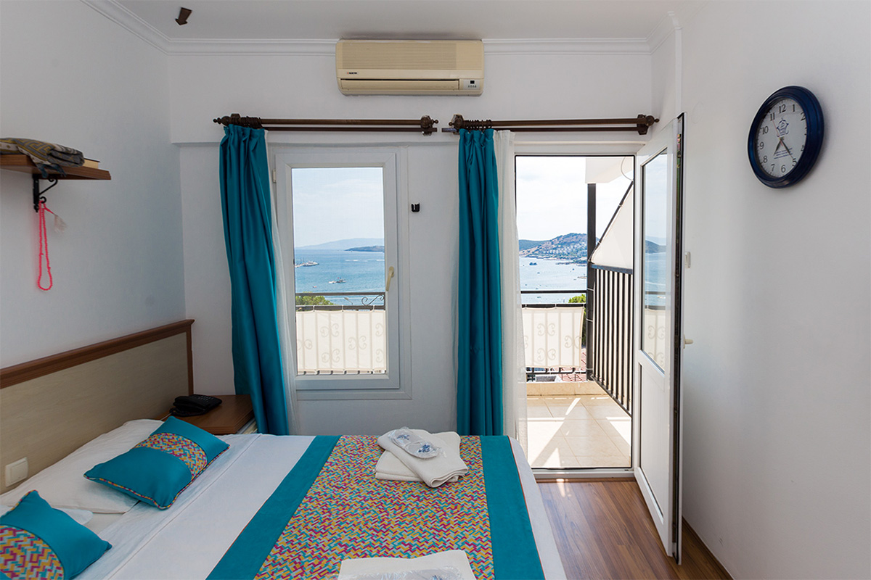
- OUR GOALS
Our organization acts in line with a vision of the future that integrates sustainability principles with operational excellence, social responsibility and environmental awareness. The targets set in this context are structured in line with our short, medium and long-term strategic plans. Our goals represent not only performance indicators but also an understanding that considers stakeholder satisfaction, local development, and ecosystem integrity.
- To reduce energy and water consumption by 2%
- Within the scope of the Zero Waste target, to increase the waste separation rate to over 80%
- Increasing the number of sustainability and accessibility trainings for all employees
- Reducing chemical use by 2% per person
- Increasing our annual average guest satisfaction by 1%
- Increasing the share of renewable energy sources to over 30%
- Increasing the number of native plants in the biodiversity monitoring system by 2%
- Reducing carbon footprint by 1%
- Leading destination-specific nature conservation and community development projects
Our goals are supported by regular monitoring, measurement and evaluation mechanisms; a dynamic management approach is adopted by revising it when necessary. In this way, our sustainability performance will be directed in a way that is not only reportable but also transformative, and visible tangible results will be achieved.
